DOCUMENT EXPLANATION: Early stage testing, functional testing, visual testing, code validation,
post functional and visual testing and code validation user feedback to see if the outcomes quality has improved.

Contents links:
- Early stage feedback
- Functional testing table
- Multiple VW device testing table
- Visual and aesthetical testing table
- Code validation
- Final stage feedback (real user case)
KEY: Highlighted rows are logs / tests are more thorough examples my testing and refinement process.

Early stage Feedback - Aesthetics
Date: | Name | What you liked | My suggested Improvements for you should make: | Changes made:
5/08/26 | Nikhil | Does your eye go to the most important thing first?  My eye was attracted to the glowing button first on the landing page, so yes I think so, on the home page they are drawn to colourful widgets first, which is good.  Do colours, fonts, and spacing feel consistent?  I think that it has a nice colour scheme. And there are some nice aminations that you have added from the nicegui. I like the urbanist font the most out of the two options.  Does the style suit the audience and purpose?  The colour scheme feels very mature which is perfect for an investment journal platform. | I think the next step is adding a enter button or making it so you can enter your name by clicking the enter button on your keyboard. I also feel that you could make the writing a little bit bigger because there is so much space that isn’t really doing anything . I also think that you should add a font resizer tool and an accessibility menu. While your small font is visually appealing, those with poor eyesight may not be able to read the text, so adding a resizer would make the interface more user friendly for a wider variety of users. | Removed the name entry input + button because I felt like it didn’t serve a purpose.  Added a text resizer.
11/08/2026 | Kevin | Does your eye go to the most important thing first?  It’s very neat, great lighting, cool halo button design, Great title, Pressing the button gives off full highlights. Cool Loading screen 10/10. Very neat so eyes don’t hurt/no distractions. So yes it does go to the most important thing.  Do colours, fonts, and spacing feel consistent?  Yes everything is spread out, it’s very consistent, all the buttons are smooth and working. Colours really work well together, the pumpkin orange colour gives of a luxury vibe.  Does the style suit the audience and purpose?  Yes as this website is designed towards people who like analysis and investing. | Put some more contents on the front of the page. I like the urbanist font the most out of the two options. | 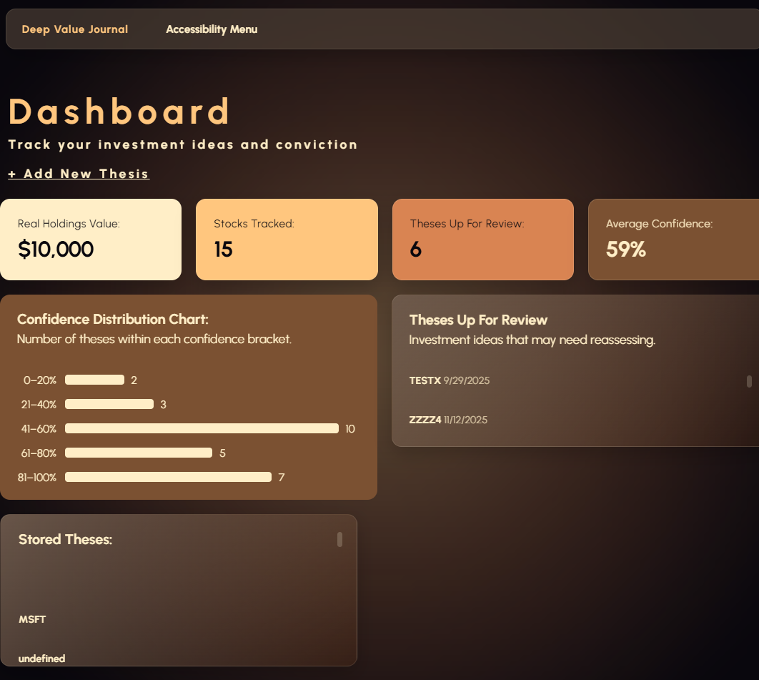  I put more content on the dashboard, added widgets to the home page. As well as a average confidence chart and theses needing review. Major redesign done.
Nikhil | 1/08/26 | 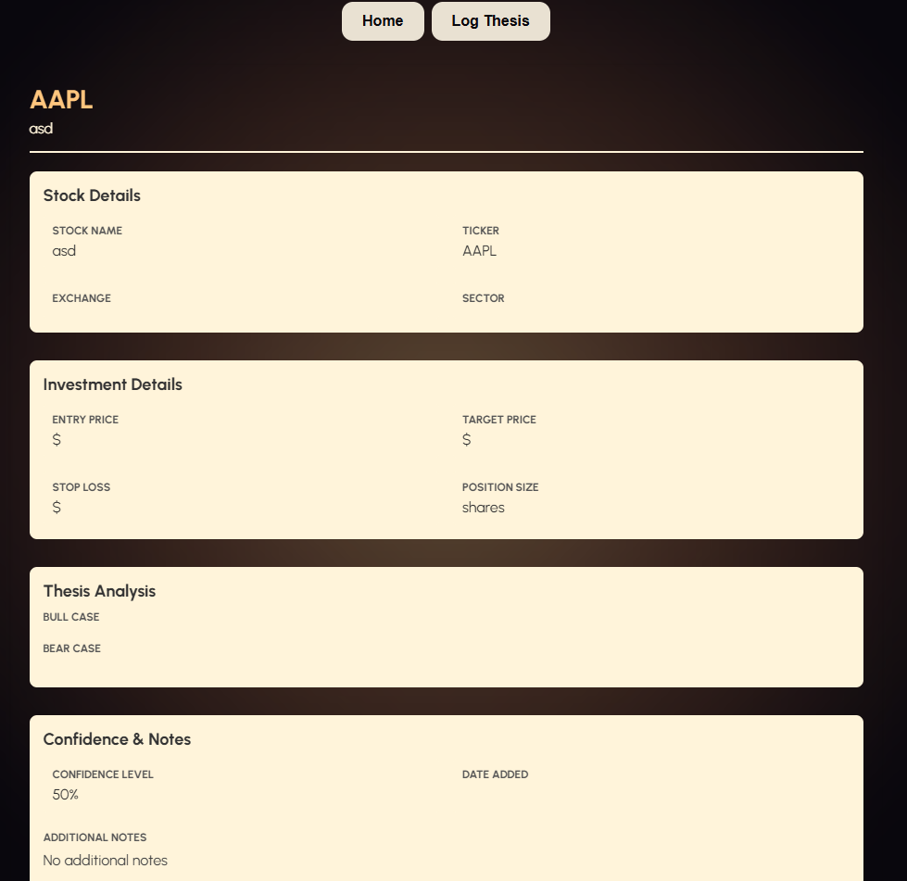  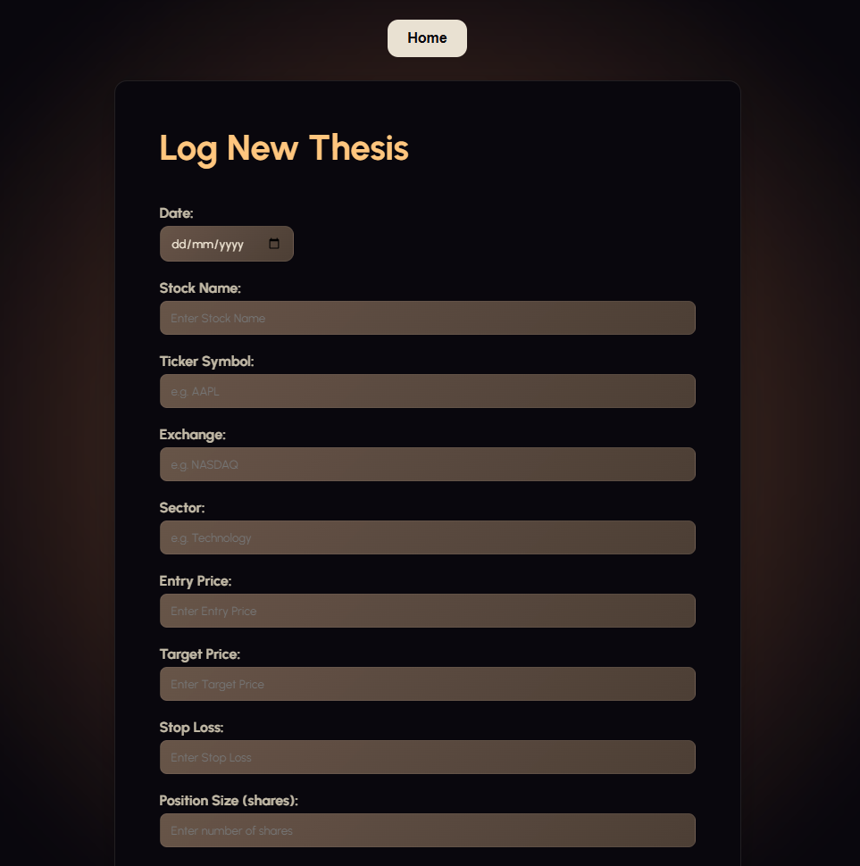  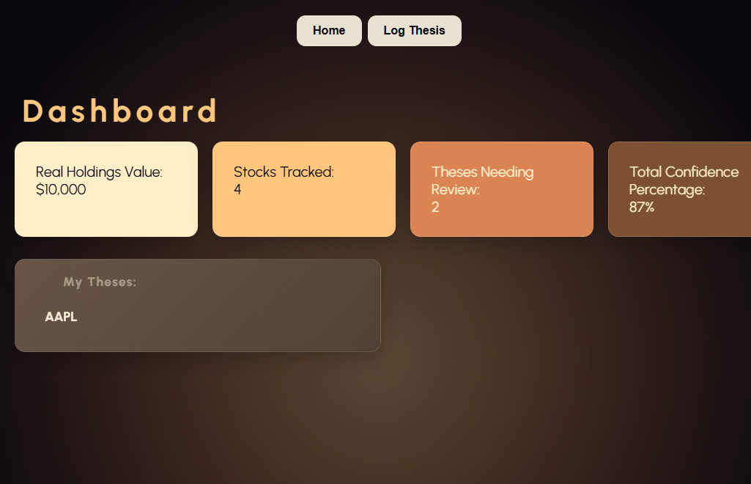  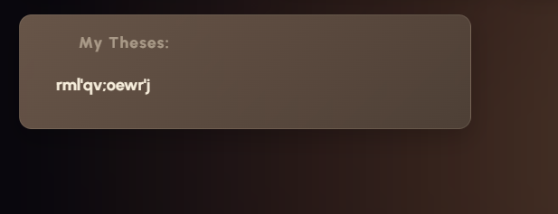  I think that it looks good, and that the structure and flex box are all working good when the dimensions get smaller. | I do wonder whether a lot of text is going to contrast well with the background and the colour of text you have chosen. I think you should either change the colours or make an accessibility button that makes it so you can change the contrast. On the log page you could change the colour of text in the input box as it is quite hard to read. I think that you could do some error prevention because right now you can spam the keyboard and it accepts it. I also think the navigation bar looks clunky, and the add new thesis button is already above the navigation widgets. I think you should remove the log thesis button at the top. | I have removed the log new thesis in the navigation bar. + restyled it to have better contrast, and look better.  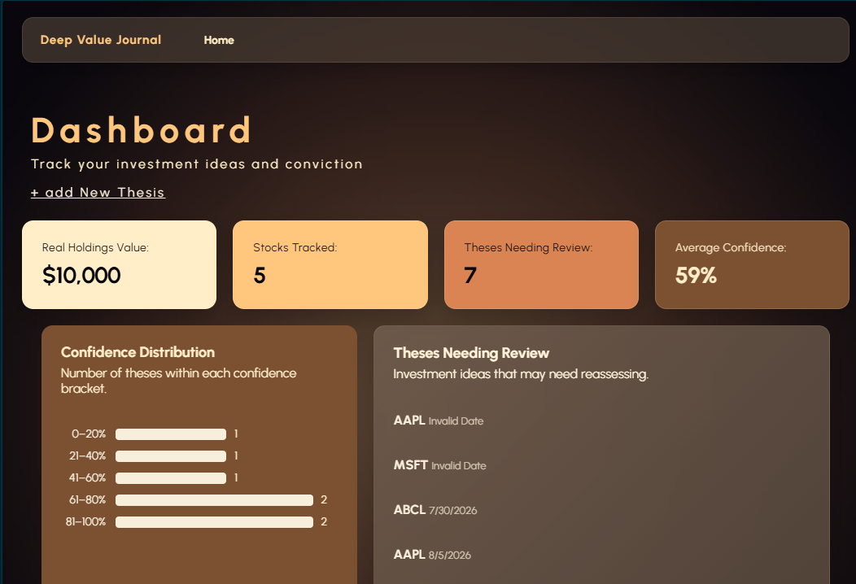  Changed the colour of the text in the input boxes on my form – see aesthetic optimizations section (click here)  
Nikhil | 31/08/26 | 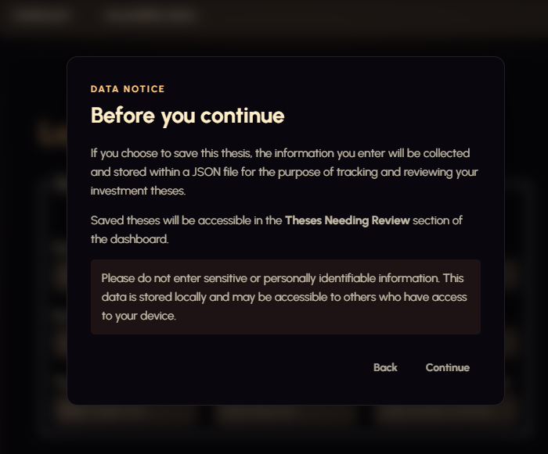 | I think that the contrast between the disclaimer background and the text is too little. Its black and grey. It is important to have high contrast on the disclaimer because is an important message about privacy, so legibility matters. | Tested for contrast on my disclaimer between the <p> text and the background. Updated it to be higher contrast by changing the grey to the off-white colour present throughout my interface.  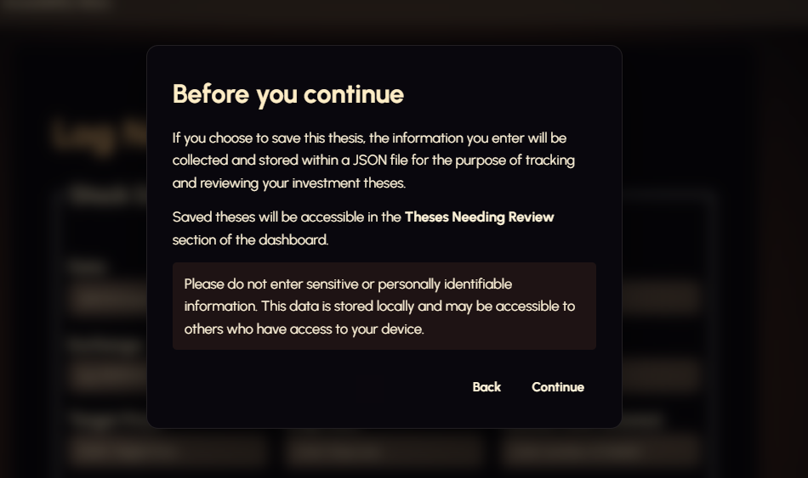  Nikhils feedback after my changes: I think the contrast of the disclaimer has improved quite a lot, and it was easier for me to read the text.
Nikhil | 3/09/26 | 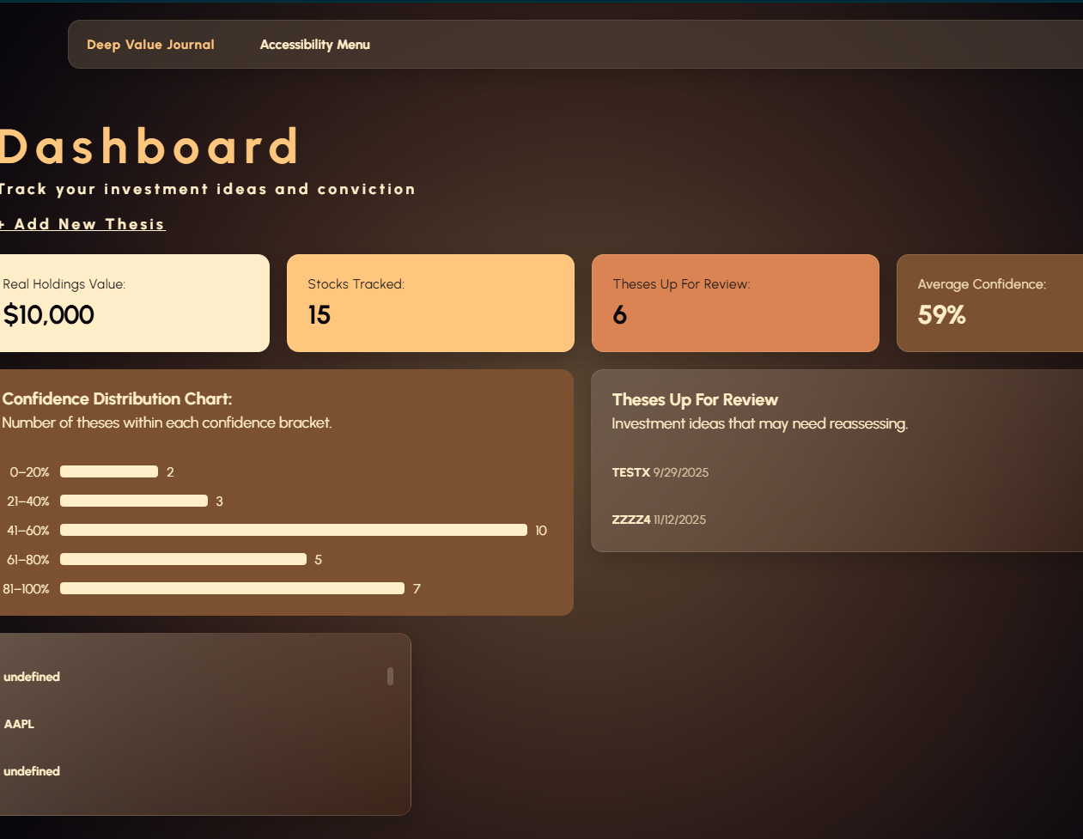 | Accessibility menu looks like a navigation button when it is placed on the right hand side of my navigation bar, as this is common convention for navigation elements. This leaves the user confused because they think the accessibility menu would navigate them to another page, rather than bringing up a pop-up.
Nikhil | 4/09/26 |  | I think the letter spacing for the dashboard title is too large, meaning that it’s a bit difficult to read having the letters spaced so far apart.  I updated the letter spacing for the h1.welcome css to 0.1em instead of 0.16, reducing the spacing between letters. | 0.16em letter spacing:  0.1em letter spacing:    Nikhil’s feedback on my change: I really like prefer the 0.1em letter spacing over the 0.16em letter spacing, I think it does improve the readability of the title and makes the interface look more refined.

Main functional testing table
Date tested: | UI part / feature | Test input / action | Expected result | Actual result | Pass / fail | Changes made | Why this benefits the user experience / makes the device more inclusive to use
15/08 | Enter New Thesis form | Trying to log a new thesis without entering a stock ticker or name | The interface should stop me from doing this and provide an error message | I get a popup message on the screen that says please fill in the stock ticker and name sections | Pass | No changes need to be made | Precents incomplete data from being stored. This ensures that every saved thesis has the identifying information required for the user to find and recognise it later in the my theses section.
15/08 | Enter New Thesis form | Trying to log a thesis with no date | Interface should display an error message and stop me from being able to go through with this | Message ‘Thesis saved successfully’ and thesis logged in my saved theses box on dashboard | Fail | Added proper date checking + an error message to stop the user from submitting date-less forms  if (!thesis.date) {  alert("Please add a Date");  return;  } | Prevents incomplete records: Every thesis has the basic information needed to identify when it was created.  Makes the dashboard more useful: Dates can be used when displaying and reviewing theses, so missing dates could make the information confusing.
15/08 | Enter New Thesis form | Trying to log a thesis with no date | Interface should display an error message and stop me from being able to go through with this | ‘Please add a date message’ and form not submitting | Pass
15/08 | Enter New Thesis form | Trying to add stock tickers with special characters and numbers | 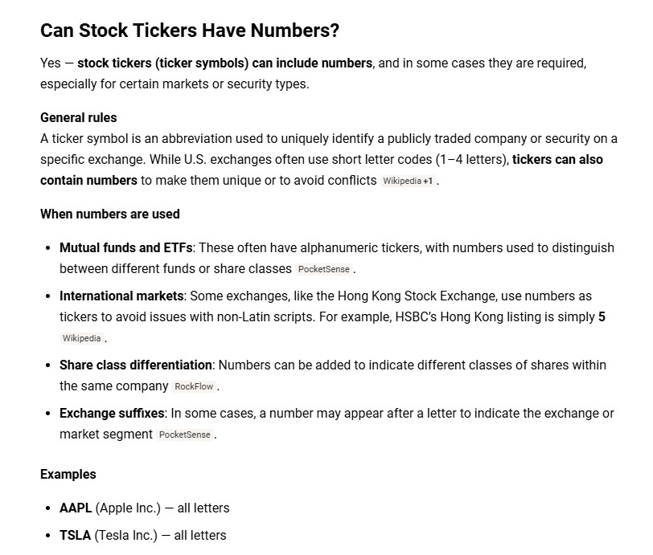  Interface should stop me entering the special characters while numbers are allowed because they are required sometimes in different exchanges. | 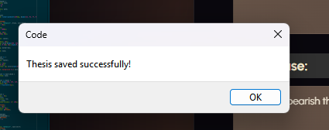  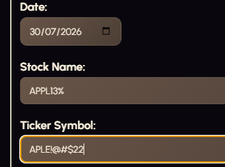 | Fail | Changes:  if (!/^[A-Za-z0-9 .&'-]+$/.test(thesis.stockName)) {  alert("Stock Name contains invalid characters.");  return;  }  if (!/^[A-Za-z0-9.-]+$/.test(thesis.ticker)) {  alert("Ticker Symbol contains invalid characters.");  return;  }  /^[A-Za-z0-9 .&'-]+$/  This means:  - A-Z → uppercase letters  - a-z → lowercase letters  - 0-9 → numbers  - → spaces  - . → periods  - & → ampersands  - ' → apostrophes  - - → hyphens  - + → one or more characters  This checks to see if the stock name or ticker has special characters and then presents the error message if it does.  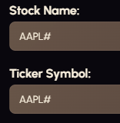  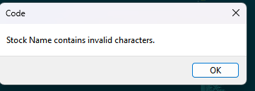 | This benefits the user experience because it stops the user from entering theses with confusing names that don’t connect to actual stock tickers. This helps with the readability of saved theses, and keeping cognitive load while using the interface down
29/08/26 | Navigation bar on home page | Click each navigation button | Each button should open the correct page and the accessibility menu should open nicely. | Both buttons work. The accessibility menu does open nicely, although when I press the home button while on the home page it reloads. This isn’t a great thing to have really. | Partial Pass | I think the fix for the home button reloading the page issue is just removing it from the dashboard page.   |   this change improves usability because removing the home button on the dashboard prevents the user from making a redundant action, pressing the home button while on the effective home page just reloads the page rather than providing useful navigation. This helps to simplify the interface to make it more intuitive and reduces unnecessary user input.
29/08/26 | Add new thesis form | Enter a complete thesis and save it | I should be able to access the entire saved thesis in the saved theses section. It should be laid out in a nice clean layout too. | 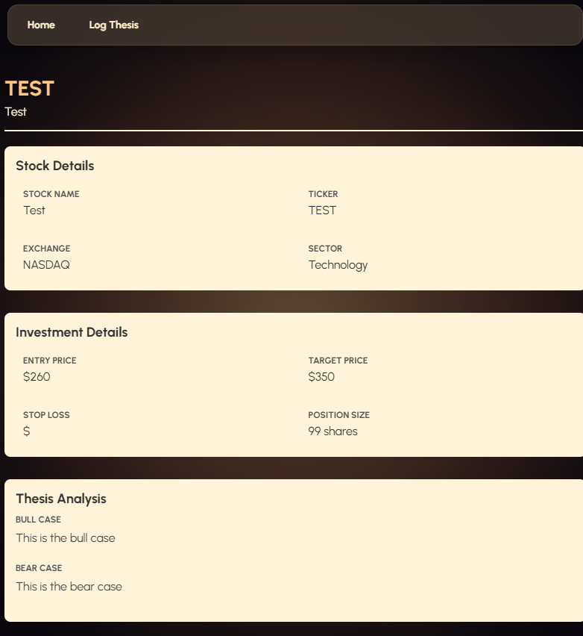    Thesis saves properly and the layout is very easy to understand with | Pass | No changes made, works as expected, all the information I entered is there
29/08/26 | Saved theses | Save a thesis and then reload the page | If the local storage works properly the thesis should stay in the saved thesis section. |   after reloading the page my test thesis is still there  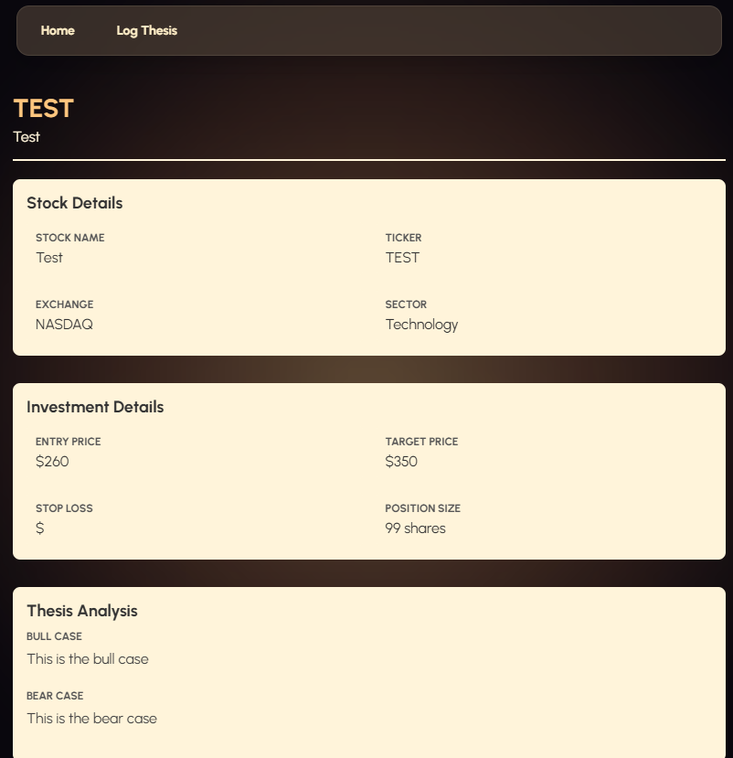 | Pass
29/08/26 | Edit thesis | Try to change an existing thesis | The original thesis should be updated and a duplicate should not be created | There is currently no way for me to edit the information saved in my theses. This is a real problem because that’s kind of the whole point of my interface. | Fail | 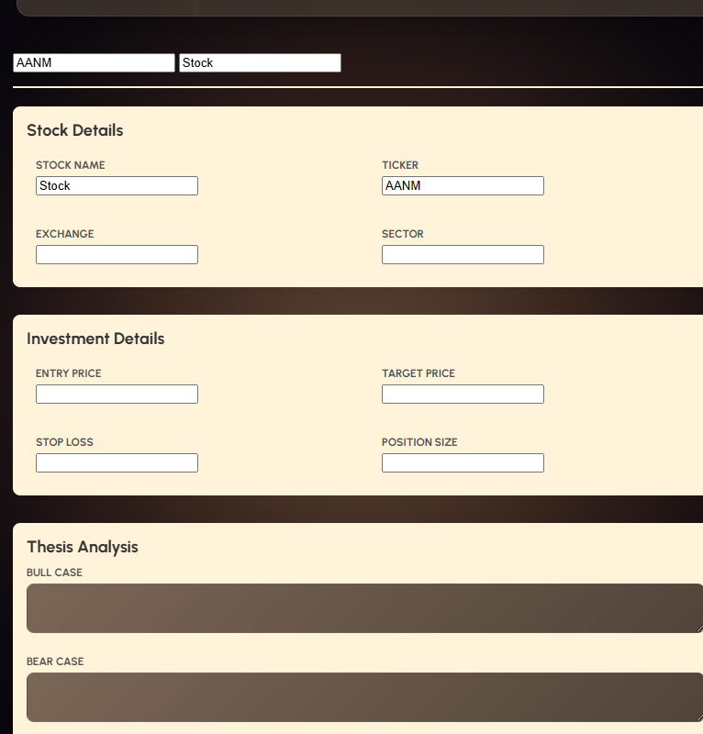  I added a system to let the user update their theses within the thesisview.html page. See worklog on 29 august for details. | This helps me achieve the actual purpose of my interface, which is allowing the user to have a place where they can easily track their theses for different stocks. It’s much easier to have the ability to edit each thesis than add a duplicate to update information, hence the required user input is decreased for using my interface.
29/08/26 | Edit Thesis | Try to remove the stock ticker, name and date from a thesis and save it | The interface should not let the user do this, as it creates a saved thesis with no identifiable name. | Interface lets it happen, leaving unclickable element in my ‘My Theses section’ | Fail | 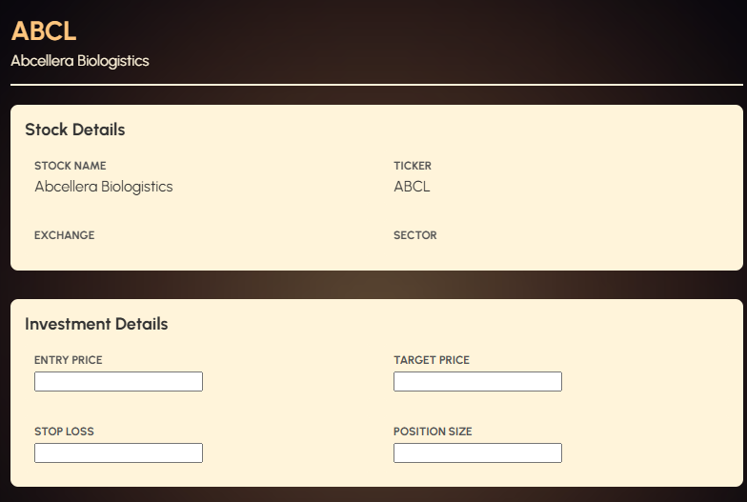  removed the ability to change stock ticker and name when editing theses, because if the user really wants to change the stock the thesis is for, they need to input a new stock through the thesis entry form instead. This ensures that the user cannot create unidentifiable elements saved to their local storage.  Actually this can go for sector and exchange too because they are all going to be specific attributes for the stock entered initially too. | This improves the user experience because it stops them from being able to create faulty theses in their my thesis section on the dashboard, so it becomes less confusing.
1/09/26 | Edit Thesis | Try to remove the stock ticker, name and date from a thesis and save it | Interface should stop me from doing this | 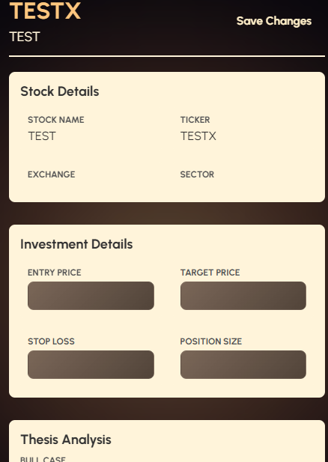  Stock ticker and stock name don’t get repopulated with an input, hence they cannot be edited. Date section has become a required field. If no date is entered I get a ‘please enter a date message’. | Pass | Testing improved the quality of my outcome here
29/08/26 | Edit Thesis | Try to enter letters and special characters into the entry price and categories that specifically need only numbers. | The system should stop the user from entering letters into spaces that only allow numbers | Interface saves my thesis without thinking twice  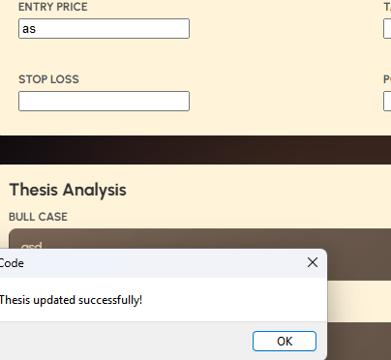 | Fail | I have made entry price, target price, stop loss, and position size number inputs which stops the user from entering letters and special characters.  I added back the confidence slider when editing the thesis, ensuring it starts on the number that the user initially put it on. | This improves the user experience because it prevents invalid data from being entered, reducing user errors and making the editing the form faster and easier to complete. Makes the interface more intuitive because users can immediately tell that only numbers are allowed in that field.
1/09/26 | Edit Thesis | Try to enter letters and special characters into the entry price and categories that specifically need only numbers. | The system should stop the user from entering letters into spaces that only allow numbers | Interface doesn’t let me enter numbers into the entry price, target price, stop loss, and position size. They have become number inputs | Pass
29/8/26 | Edit thesis | Trying to remove the date when editing a thesis and save i | Interface should stop me from doing so because a date is required for the reviewing process. |  | Fail | Adding compulsory date checking to my thesis view edit section. | Stops the user from invalidating their theses from review process by having no date. It also prevents accidental deletion by maintaining an accurate record.
1/09/26 | Edit thesis | Trying to remove the date when editing | Interface should stop me from leaving the thesis with no date filled in | 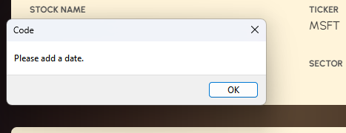  interface provides an error message if I leave the date category empty, this is kind of redundant because date is still a required category when entering a new thesis, but if one did slip through this would catch it. | Pass
29/08/26 | Edit Thesis | Pressing the edit thesis button with the edit screen already open | There should be no button to edit there in the first place as the user has already pressed it because this is redundant. Should provide no action if there is a button | Pressing the edit thesis button while already editing a thesis completely clears the thesis. This is a major problem because the validation I just made to stop the user from changing stock ticker and name means that if the thesis is completely cleared, the user will be forced to save a completely empty, unidentifiable thesis | Fail | I changed how the buttons are hidden to ensure that they disappear and appear at the right time. This stops the user from accidentally wiping their thesis completely. | This decreases the cognitive load on the user because there are less buttons on the screen that aren’t required at that specific point in time. It also makes for a more refined user experience as theses can’t delete randomly, and there is less chance of the user clicking the wrong button accidentally.
1/09/26 | Edit Thesis | Pressing the edit thesis button with the edit screen already open | There should be no button to edit there in the first place as the user has already pressed it because this is redundant. Should provide no action if there is a button | Buttons now switch between edit thesis when the thesis view page is in regular mode, and save thesis when the thesis view page is in edit mode.     | Pass
29/08/26 | Edit Thesis | Pressing home while having unsaved data when editing my thesis | Interface should prompt me to save first otherwise my data may be lost. | Interface lets me go home, no warning, losing the data I entered. | Fail | added a confirmation message to stop the user from accidentally deleting unsaved changes | This makes the user experience better because it prevents accidental data loss, ensuring users are aware of when their data is unsaved. The warning will only appear if changes have been made, which avoids unnecessary interruptions.
1/09/26 | Edit Thesis | Pressing home while having unsaved data when editing my thesis | Interface should prompt me to save first otherwise my data may be lost. | Interface does prompt me that my data will be lost if I continue  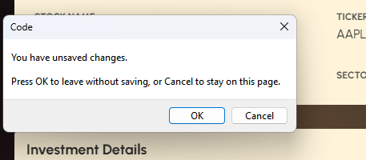 | Pass
29/08/26 | Accessibility | Changing the text size on the text size resizer | The text size resizer should work to change the size of text on all of my html pages, not just my dashboard. It should also save if I set it to something on the dashboard and then go across to another HTML page, so that the user doesn’t need to set it to their desired size again | The text size I enter does not save and I have to re enter it when switching pages | Fail | I changed the accessibility Javascript to have persisting text sizes | Improvement to the usability experience is that there is a consistent accessibility setting across the entire website. for users who need accessibility settings, it would be really frustrating to have to constantly go back and change the font size again.
29/08/26 | Data loss prevention | Pressing the dashboard button when I have unsaved information entered in the thesis entry form | Interface should provide me a warning message to stop me from accidentally loosing my data | Interface takes me back to the dashboard without giving me a warning | Fail | 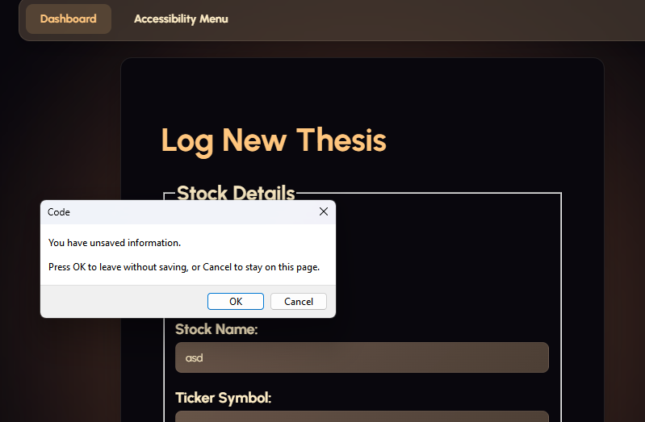  Added an error message to top the user from exiting and accidentally loosing their data | This improves the UX by protecting the user from accidentally loosing work while keeping the normal navigation experience intact and fast.
1/09/26 | Thesis form | Enter a very long thesis, | The form should save all of the data entered, not loose it or cut it off halfway to meet with margins when reviewed in the thesis view.html tab  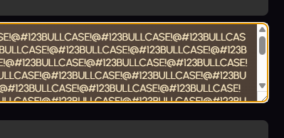 | 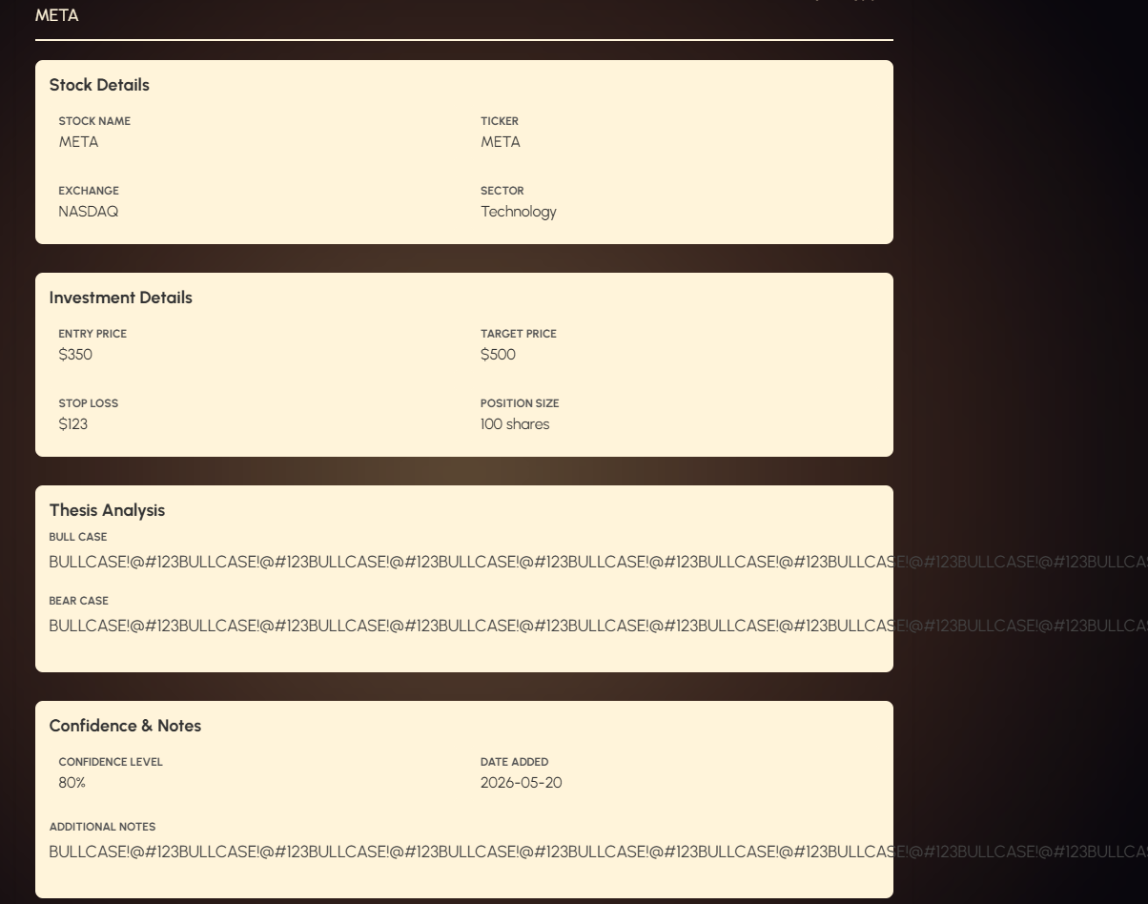  Form did retain all of the data that I entered, but it doesn’t have the ability to wrap, or for the box to grow allowing all of the text to fit inside. This means it just expands off the screen which is not optimal for a user who wants to write a long thesis and be able to easily review it later on. | Fail | Added word wrapping and breaking to my bull case, bear case and additional notes tabs.  Using CSS properties word-wrap, overflow-wrap  Break-word  I also added the same thing for the numbers in investment details, for redundancy although its unlikely to ever require the user to enter numbers so large they flow off the screen.  SEE WORK LOG ON 1/09/26 for detailed addition process. | This improves the user experience because it keeps content visible. If there was no word wrapping long text would extend off the screen, forcing users to scroll or miss information entirely. This also helps maintain a more professional appearance, and prevents UI from breaking because long thesis entries won’t distort my grid layout or push other elements out of alignment.
1/09/26 | Thesis form | Entering a very long thesis | The form should save all of the data entered, not loose it or cut it off halfway to meet with margins when reviewed in the thesis view.html tab | 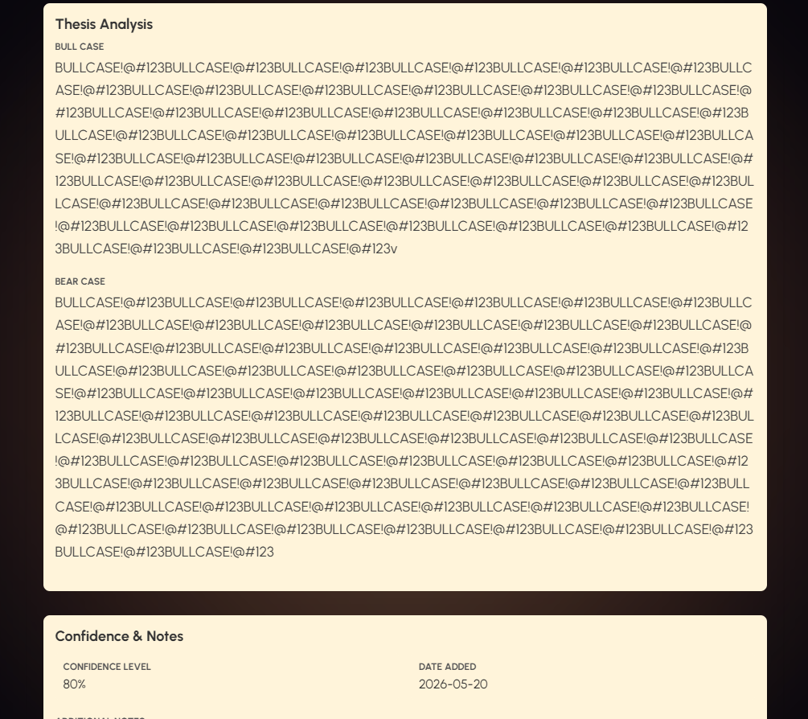 | Pass | No changes needed now, issue has been fixed.
1/09/26 | Thesis form | Enter a very long thesis, | Bull and bear case boxes should automatically add a scroll bar if text is longer than the height allows for | Scroll bar does get added when I enter a lot of text, without the box getting larger horizontally or vertically visually, ensuring that it still looks visually appealing and remains within the confines of my form | Pass | No changes need to be made
1/09/26 | Thesis saving | Reviewing the same thesis through an access point on theses needing review and also under the theses storage tab | Both links to the same thesis should take me to the same thesisview.html page with the exact same data entered, nothing corrupted or truncated. | View from theses needing review:  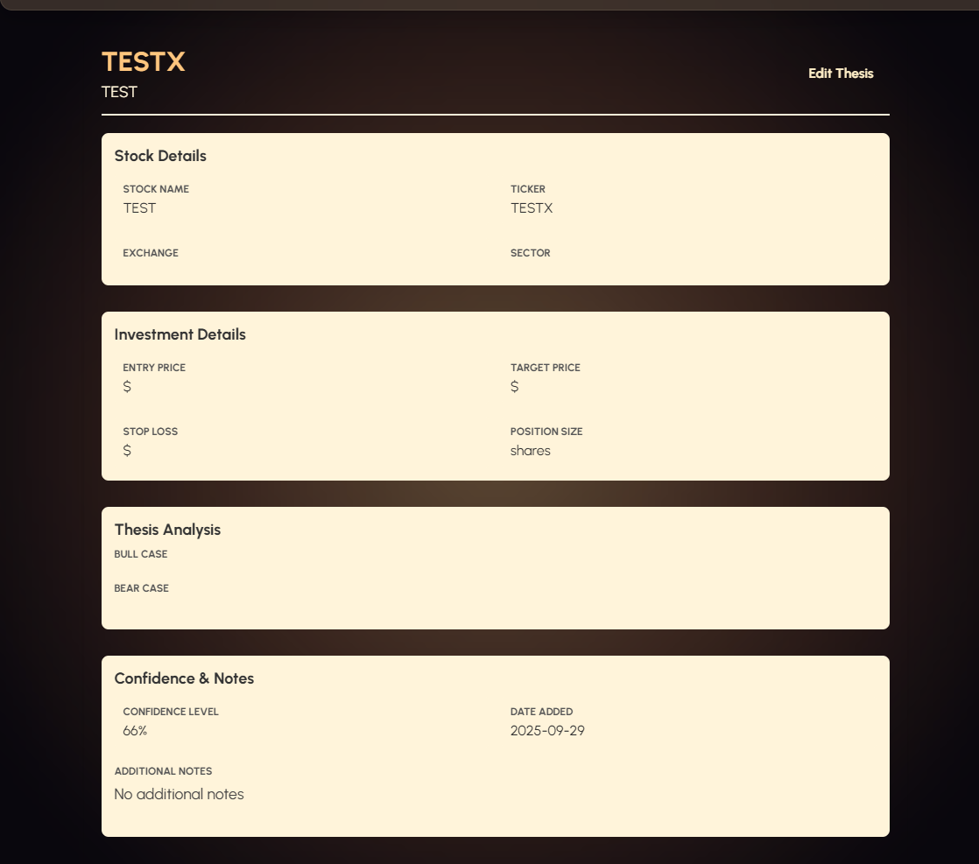  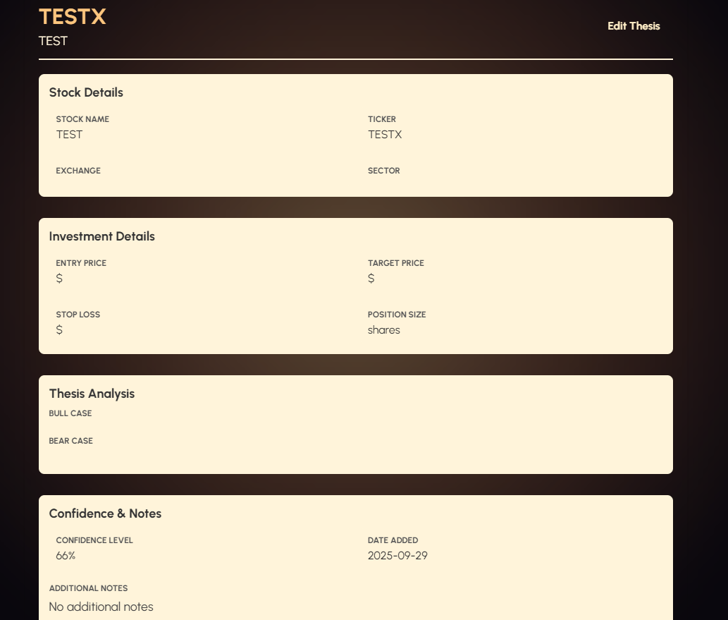  View from theses storage:  Both contain exactly the same information and in the same format | Pass | No changes need to be made
1/09/26 | Thesis saving  Thesis form.html | Pressing the submit thesis button on the thesis form without entering any data, including | Interface shouldn’t submit like it normally would. It should prompt me with a message to fill out the required fields, tell me what those are, let me click through it and go back and edit the interface. | 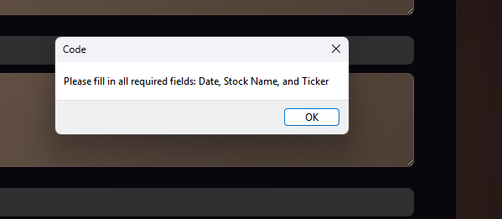  Error message prompts to me, but interface becomes un-clickable after. | Partial Pass | This is weird behaviour, but when I actually run the website on the internet rather than live preview the issue sorts itself out and I just get prompted the error message, can click through it and all the input boxes work  No changes made.
1/09/26 | Data integrity | Saving a thesis, closing and reopening the page | Information entered in the thesis and saved should persist in the thesis storage section, all the entered data should be non-corrupted and it should appear exactly as I entered it. | All data does persist and it looks the same as when I first entered it after closing and reopening the page | Pass | No changes made
1/09/26 | Thesis reviewing | Opening a thesis from the thesis storage section | All data displayed should match the stock ticker that I clicked on in the theses storage section | All data displayed is correct and matches the ticker | Pass | No changes made
1/09/26 | Thesis reviewing | Clicking on a different thesis | Should open that corresponding data, not pulling up the same data from before that’s for a different stock. | All data matches the stock ticker I clicked on | Pass | No changes made
 |  |  |  | BOUNDARY INPUT TESTING
1/09 | Theses Needing Review | Adding a thesis with a date exactly on the three month boundary (cut off for theses needing review) | Thesis handles according to the define three-month rule | 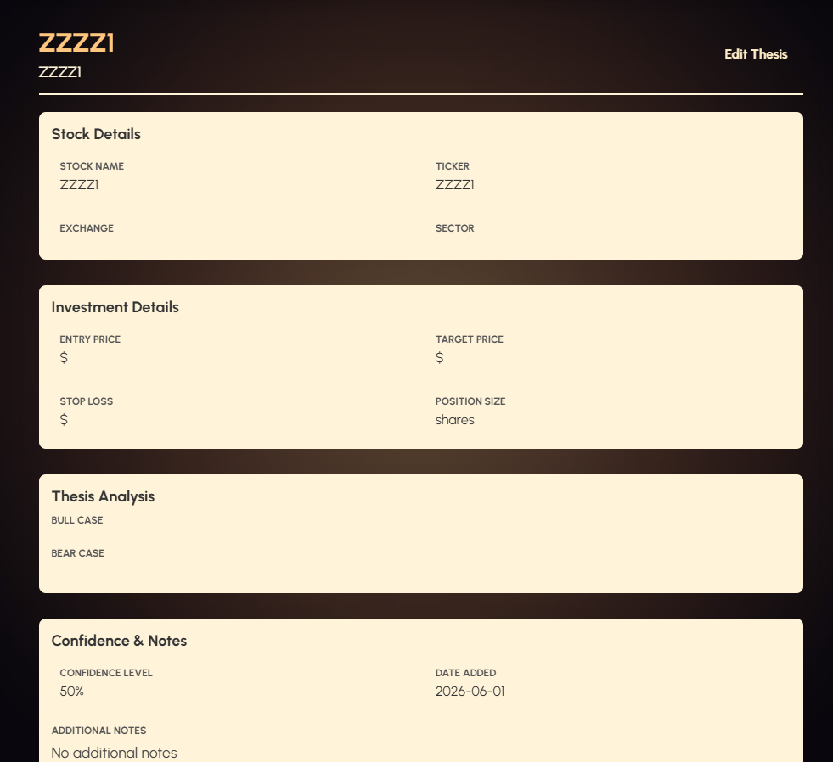  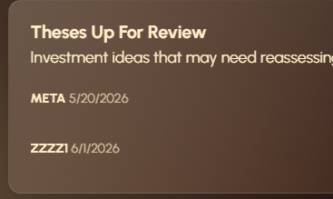  Handles the thesis created exactly three months ago well, sticking it into the theses needing review section | Pass | No changes made
1/09 | Theses Needing Review | Adding a thesis with a date of more than three months | Thesis handles according to the define three-month rule | 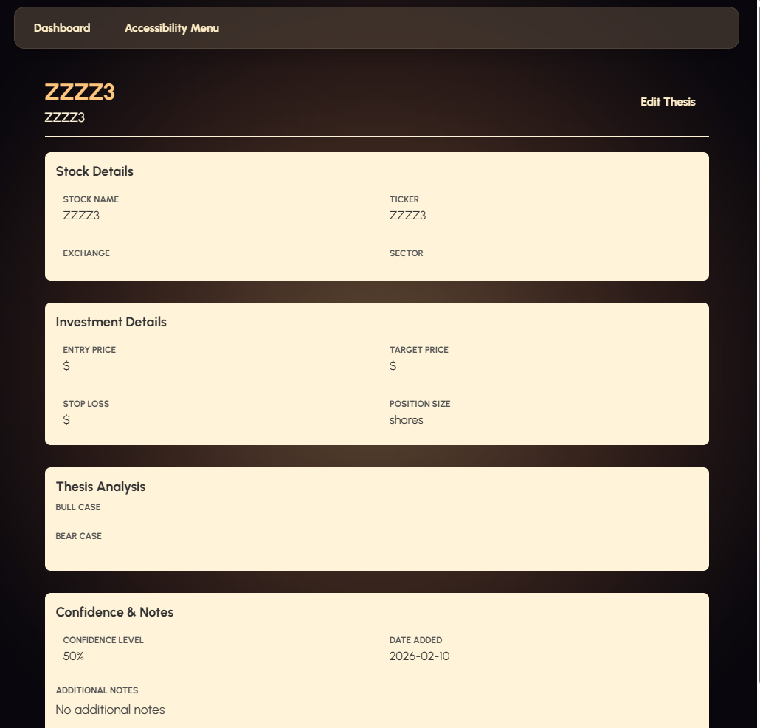  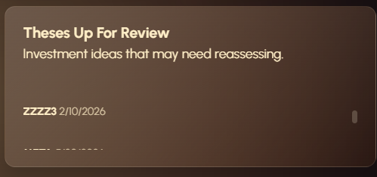  These allocated to the theses needing review section. Works as intended | Pass | No changes made
1/09 | Theses Needing Review | Adding a thesis with a date of less than three months | Thesis handles according to the define three-month rule | 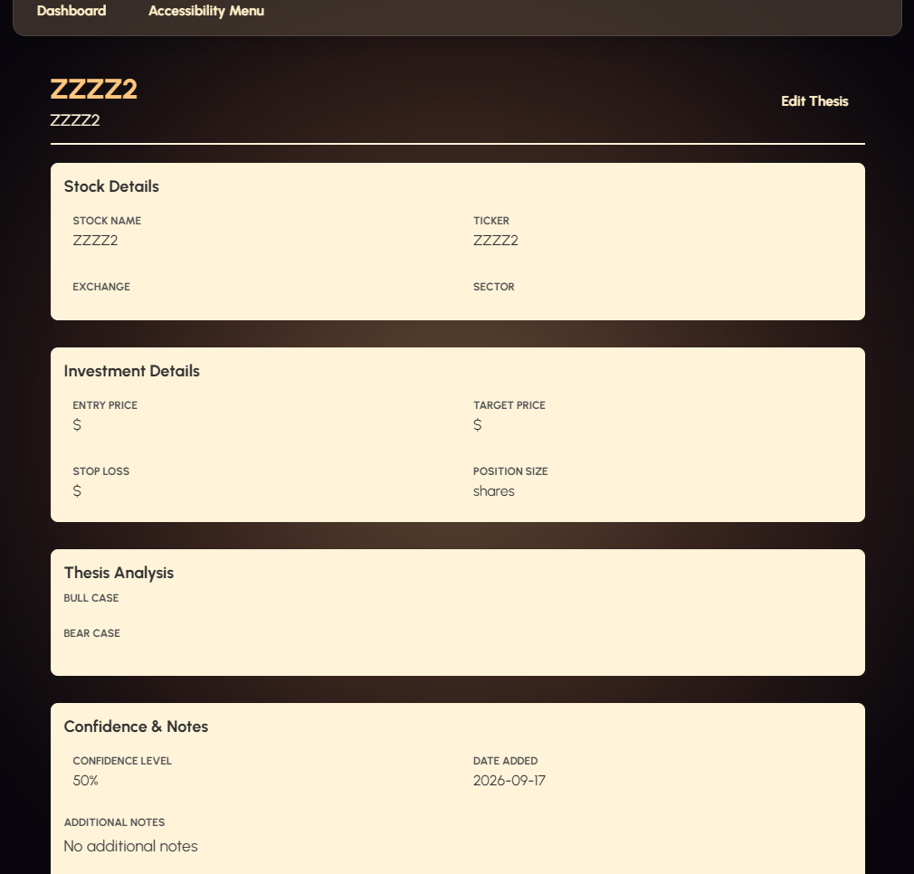  System doesn’t allocate this thesis to the theses needing review section, which is perfect, exactly as I want it to | Pass | No changes made
19/09/26 | Thesis Entry form | Trying to enter values in 0.1 increments for P/E, EPS and 52W change | System should allow them, including negative values because all of these metrics can be negative and are typically not rounded to the nearest whole number. |   system handles it and saves it as expected, replicated correctly in thesisview.html too | Pass | No changes made

What my functional testing improved:
My functional testing has helped me identify and fix errors in my interface, particularly with data saving, loading, navigation, and user inputs. Most importantly, going back to verify that my tests have worked in improving the quality of my outcome on September the first has ensured a more refined interface, designed to handle a wide range of errors, extreme use cases and bugs which may occur even later in development. The two real user tests to come on 1/09/26 are going to be used to help me verify that my changes have actually made the user experience better.

Multiple Viewport width device testing:
Date | Interface | VW tested (px) | Evidence | Notes | Changes made
29/08/26 | Dashboard | 375 | 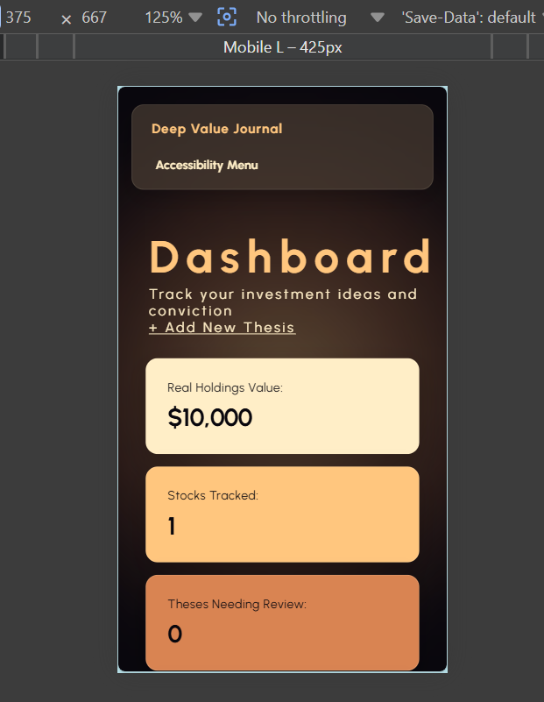 | Interface looks very visually appealing on mobile sized screens. I’m very pleased with this. Widgets stack into one single column, text remains readable. Text resizer even works and looks good.
29/08/26 | Dashboard | 650 | 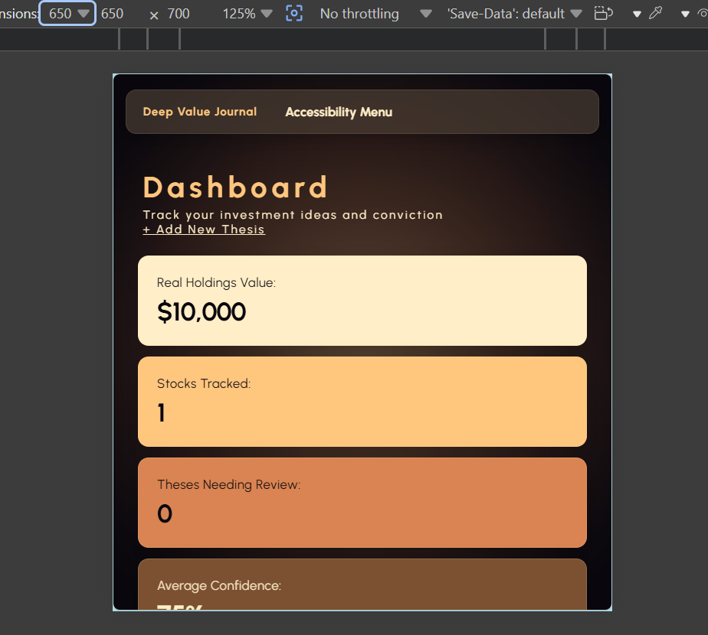 | Interface looks very visually appealing on 650px vw sized screens. The widgets stack nicely, and I still think they look good being a little bit wider than the mobile screen. The text is viewable too, and if it wasn’t the user could use the accessibility menu to resize it anyway.
29/08/26 | Dashboard | 900 | 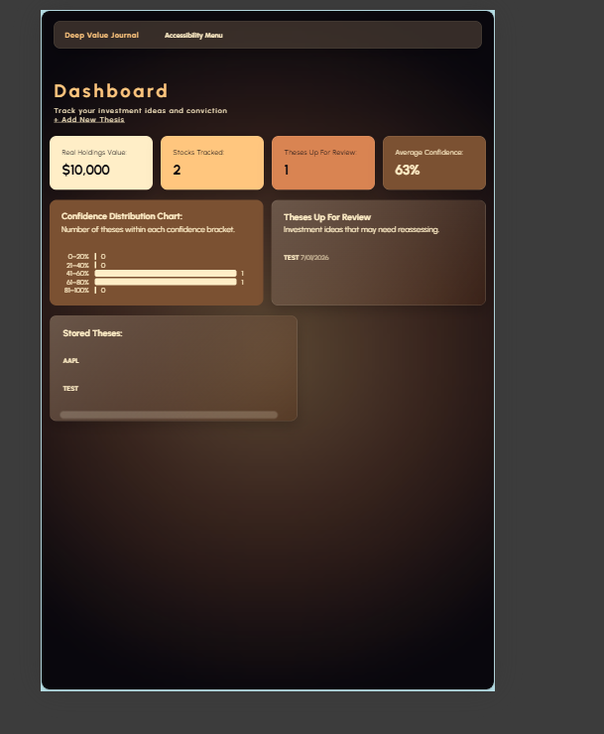 | Most of the components look as they should, widgets look nice and they are legible. The confidence chart and theses up for review stack nicely in a visually appealing way.  A fix:  My concern is that the bars on the confidence distribution chart are too close together at this VW making it difficult to read to see the difference between their lengths and see which bar is representing what. | 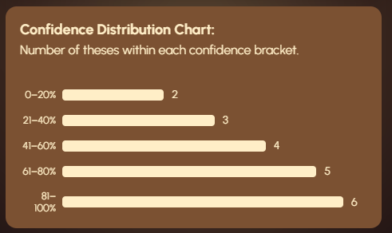  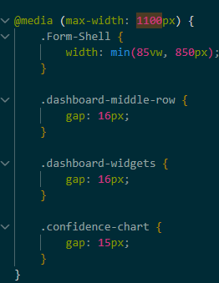  Added a 15 px gap between the chart bars for my 1100px VW and below media queries
29/08/26 | Dashboard | 1440 | 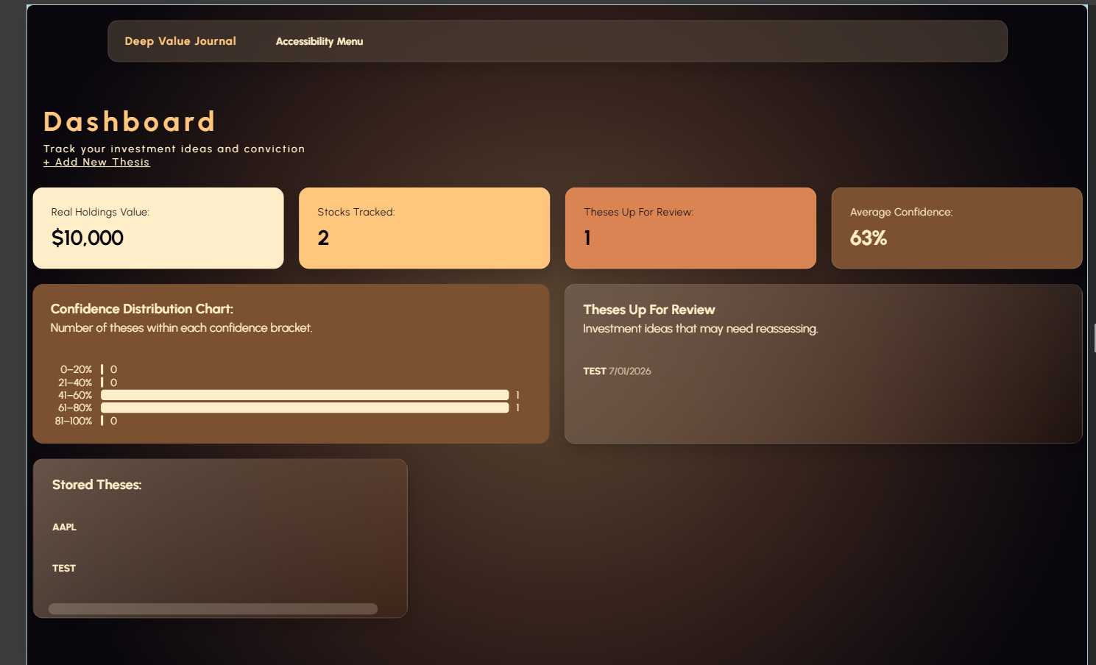 | Widgets are stacking nicely  A fix:  Same issue with the confidence chart bars being too close together | The change to my 1100px media queries doesn’t fix the bar issue on this sized VW because its much bigger than 1100px.  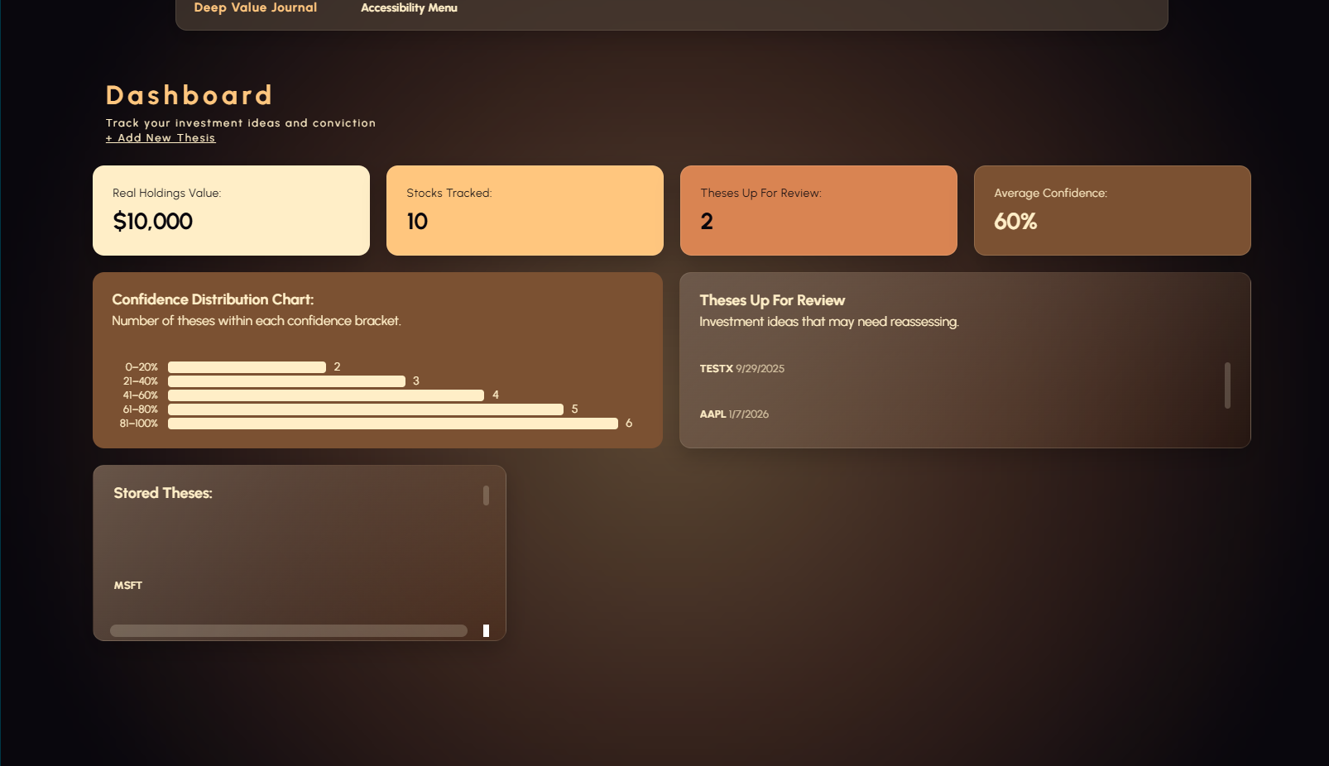  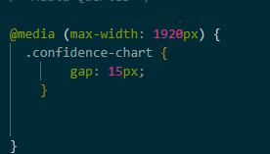  fix:  Added a 1920px media query to add a 15px gap between bars on large desktop screens. This makes the interface more responsive, and easier to specially modify if I change my mind about the spacing later.  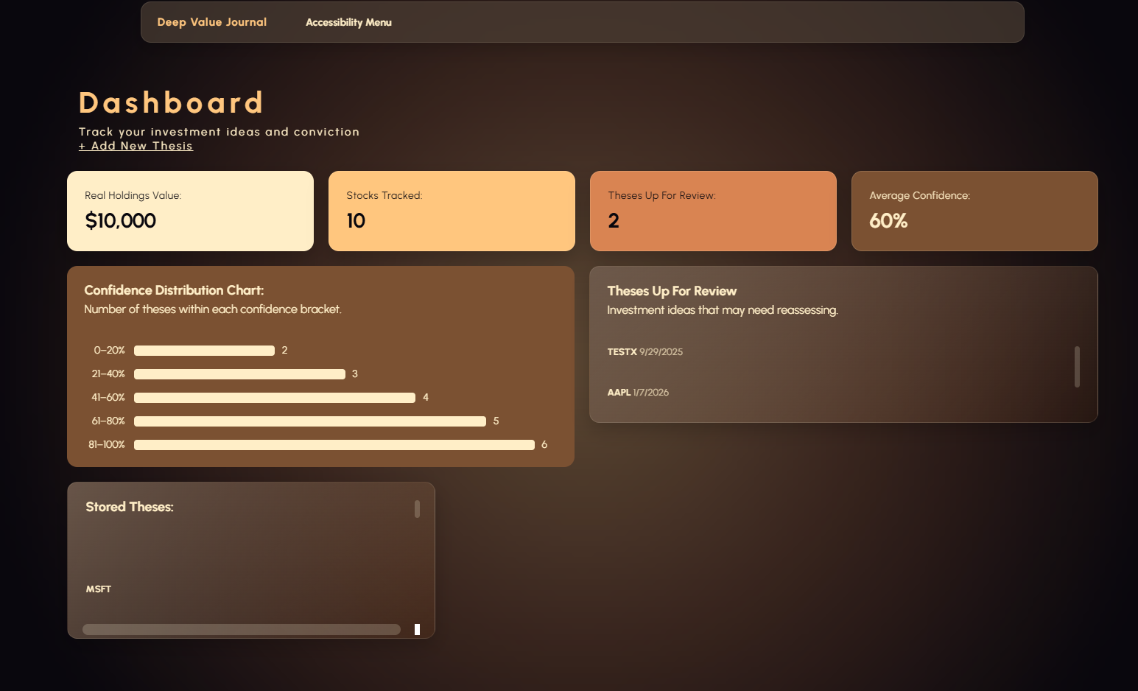  Looks great!
29/08/26 | Dashboard | 1920 | 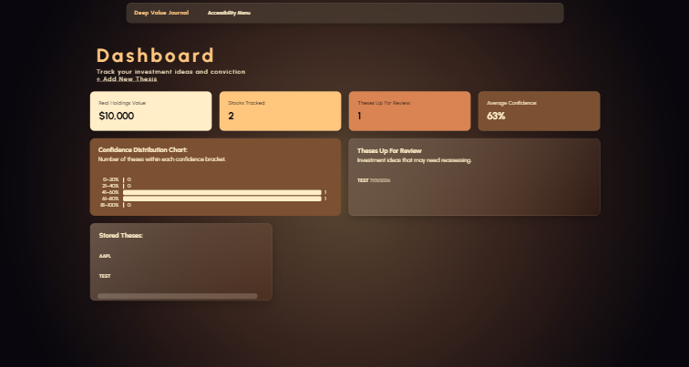 | There is a bit more whitespace around the widgets on a large desktop screen, but I feel like this is good. It could feel too overpowering if it filled up the entire screen width my widgets and charts.
29/08/26 | Form | 375 | 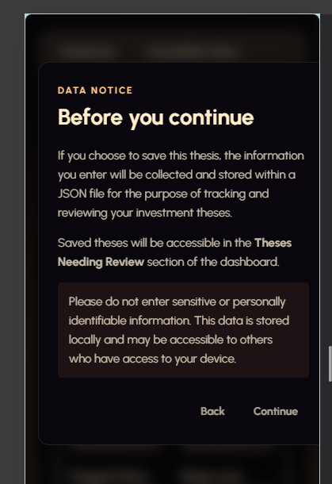  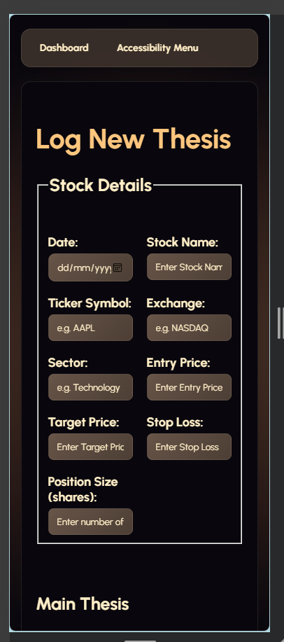 | Media queries for stacking the stock details into 2 columns on mobile screen is working properly, and I think it looks good.  A fix:  The disclaimer isn’t centred, there is no margin on the right hand side.  A fix:  The buttons in the navigation bar aren’t centred properly on 375px VW on my form.
29/08/26 | Form | 650 | 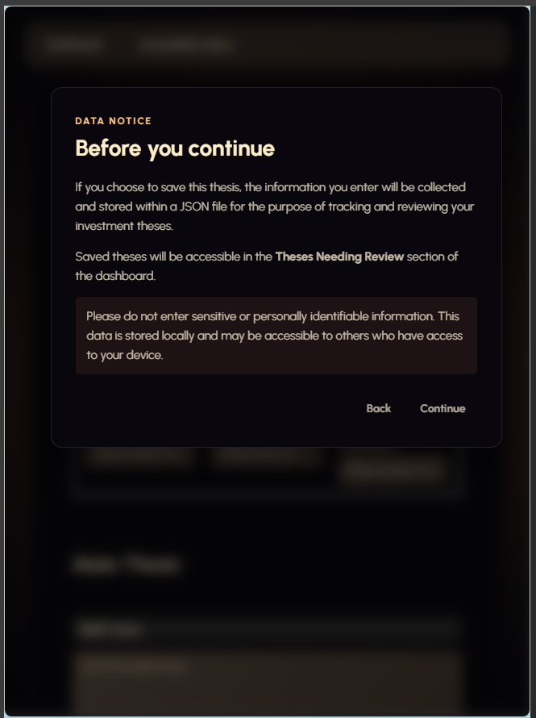  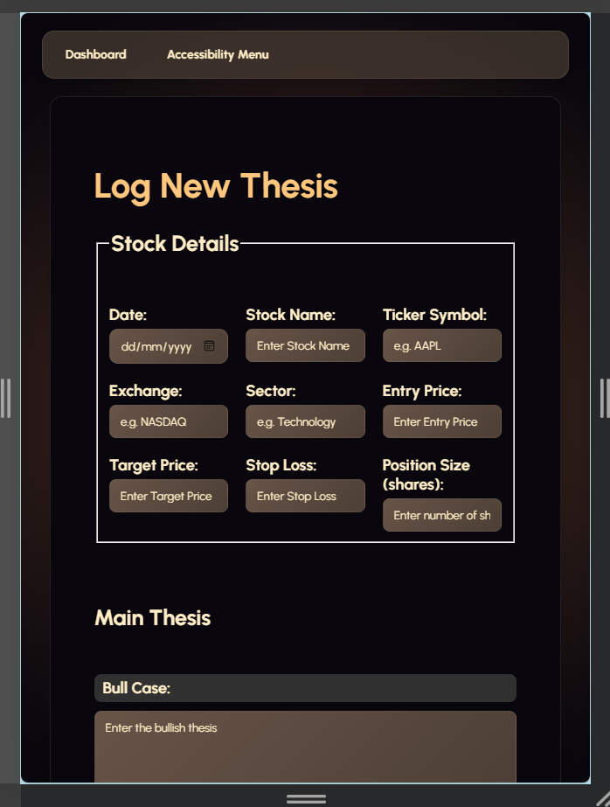 | Now that the navigation bar is wider, it looks more natural having the dashboard and accessibility button aligned to the left. It doesn’t look like it was accidentally had too large of a margin on the right side  Fix:  Disclaimer also has a disproportionately small right hand margin.
29/08/26 | Form | 900 | 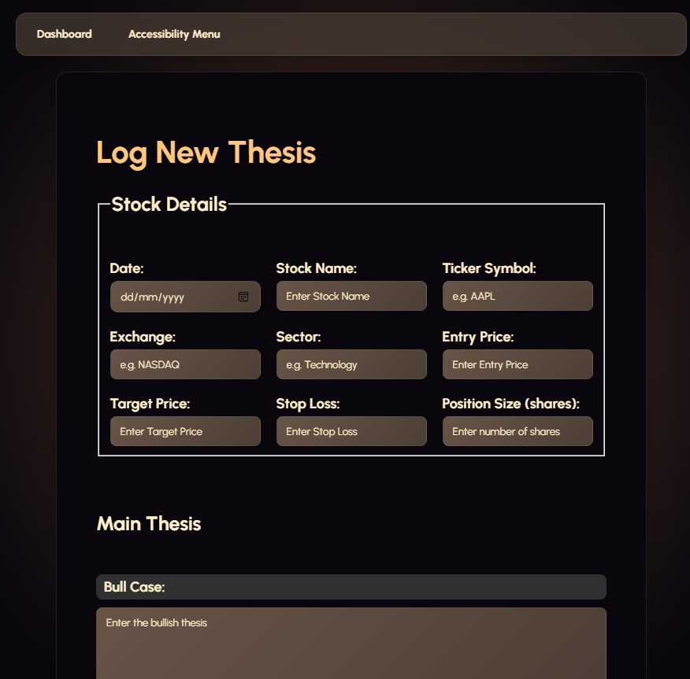 | Everything looks pretty natural  Fix:  Same issue with the disclaimer being off centred.
29/08/26 | Form | 1440 | 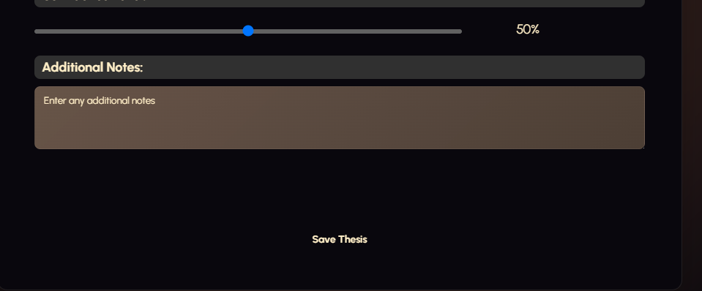 | Everything looks good  Fix:  Save thesis button is too far down and feels disconnected from the form.
29/08/26 | Form | 1920 | 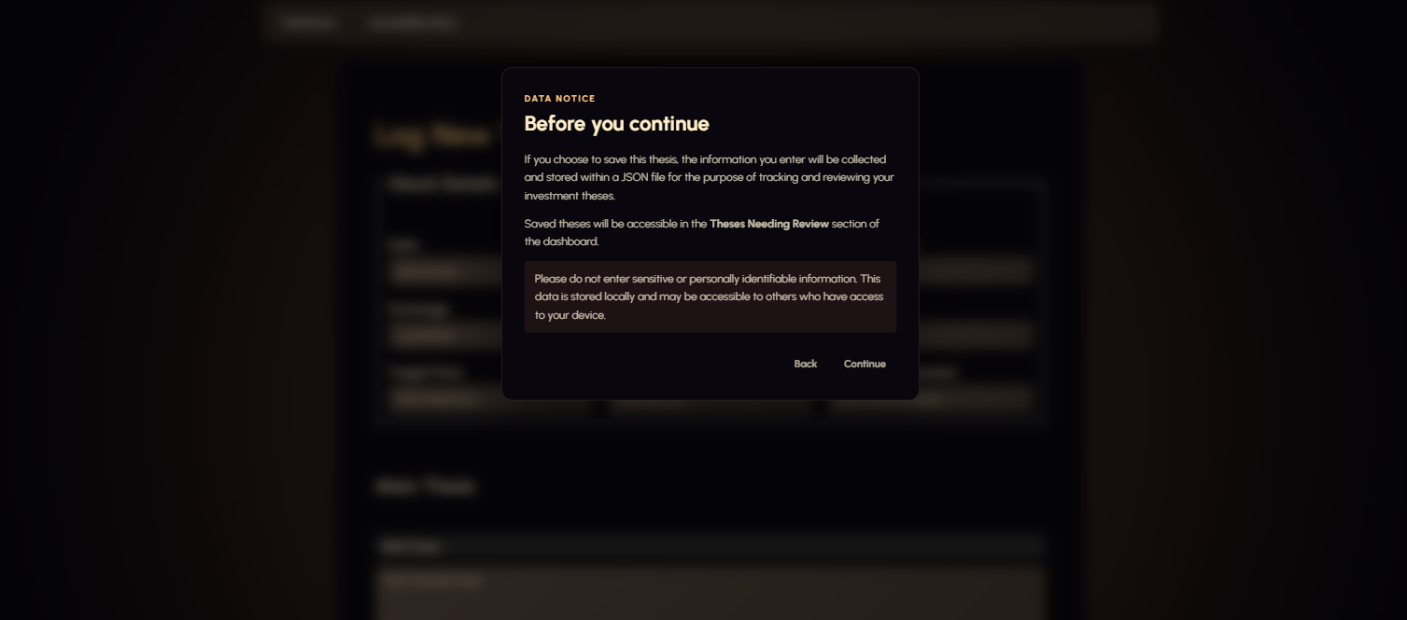  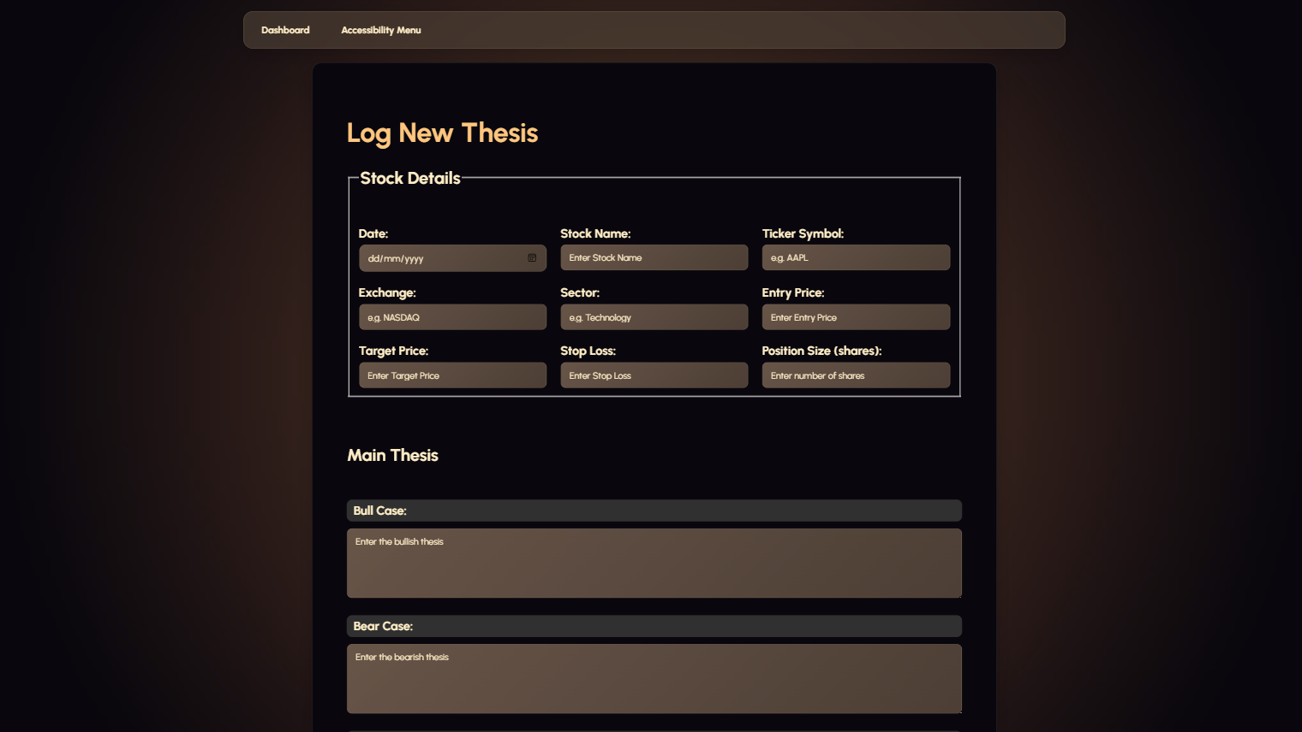 | Fix:  Disclaimer doesn’t take up enough of the VW

Testing of aesthetics and layout for optimizations and refinement log + some more Multiple Viewport width device testing
( Criteria: Include before/after screenshots for layout, contrast, or navigation improvements)
Showing results for contents of text-input area (checked with vnu 26.8.21) - Nu Html Checker

Date: | Before picture | After picture |  |  |  | Explanation of changes
10th of august |   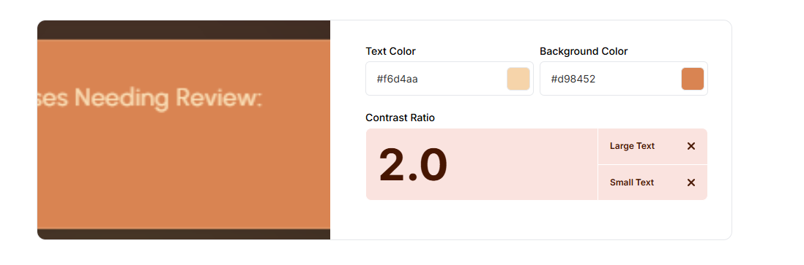  This is the contrast checker for the place holder text on my input boxes on my form. This reads it as having a contrast ratio of 1:1.6, which is terrible. While this |  | 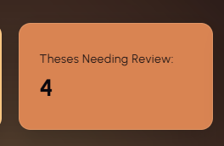 |  |  | I need to change the font on this apricot orange widget from the off white colour I use because the contrast is so poor that its really hard to read even normally. I’m going to update it to the same black colour as the two widgets beside it. Much higher contrast and easier to read.
18th of august | 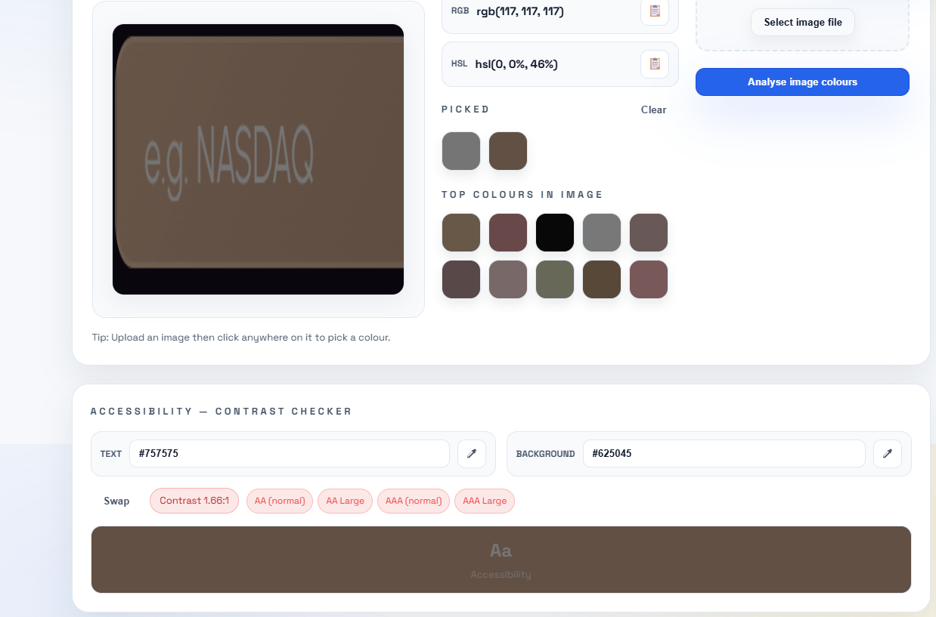 |  | 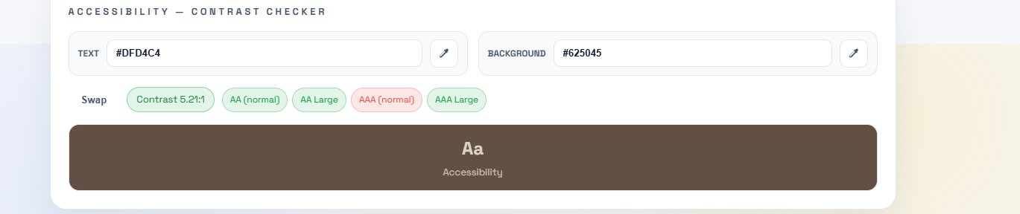 |  |  | text is supposed to be subtle, it would almost be better removing it at this contrast level. To fix this I will change it to something of higher contrast,  The issue was my placeholder text was never given a value, so it gets assigned to the browser default, which is this unassuming grey. While this would be okay for other platforms, the contrast is simply not going to work for mine.  To fix this I added this code, which specifically targets the placeholder text of my input boxes for my whole form, rather than before where I was trying to style the divs that the input boxes were in, and of course this just changes the colour of the text that the user can type.  input::placeholder,  textarea::placeholder {  color: #F7EEDC;  opacity: 1;  }  This gives a contrast of 5.6, while not the best, I actually don’t want it to stand out a huge amount because its only supposed to be subtle.
23/08/26 | 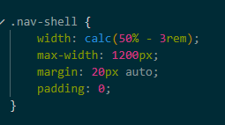 |  | 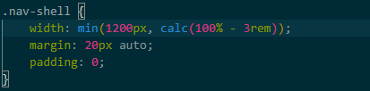 |  |  | Layout optimization: changed the rules for the width of my navigation bar on large screens to take grow up to 1200px rather than staying at 50%
23/08/26 | 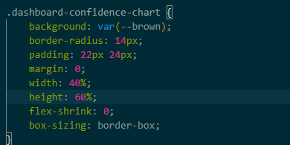 |  | 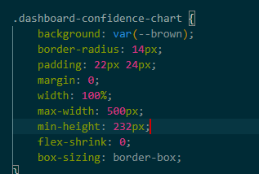 |  |  | Replaced percentage-based width and height with width: 100%, max-width, and min-height. This improves responsiveness and prevents the chart from becoming incorrectly sized on different screen dimensions.
23/08/26 | 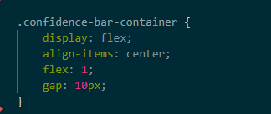 |  | 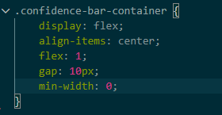 |  |  | Added min-width: 0 to the confidence bar container so flex content can shrink correctly on small screens and prevent horizontal overflow.
23/08/26 | 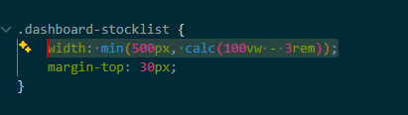 |  | 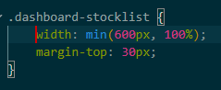 |  |  | Changed the rule for the stock list. The old rule was tied to viewport width and could behave weirdly inside dashboard-home which controls page width already.  New version tells my stockiest to use available with but do not exceed 600px.
23/08/26 |  |  | 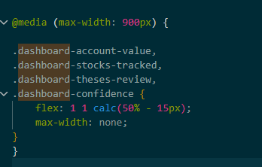 |  |  | Added a 900px breakpoint to flex dashboard widgets into two columns. This provides layout for tablets smaller laptop screens.
23/08/26 |  |  | 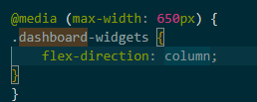 |  |  | Added a proper mobile layout, that changes dashboard widgets into a single column layout to ensure they remain readable.
23/08/26 |  |  | 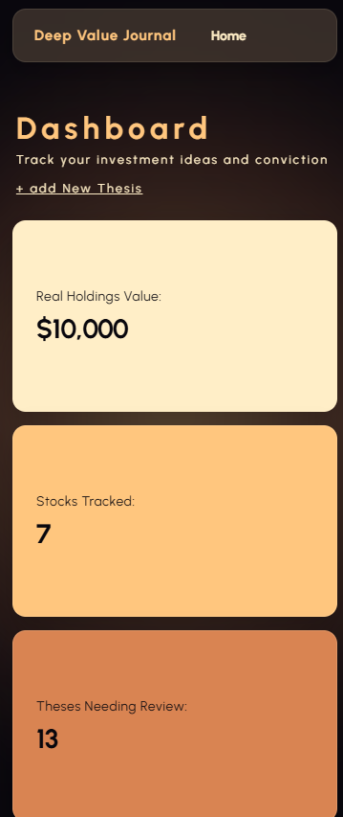  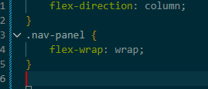 |  |  | Future error prevention added to navigation bar under mobile layout. I do not have enough buttons to require flexing in my nav bar on phones, but if I were to add them later on they would be covered.
24/08/26 | 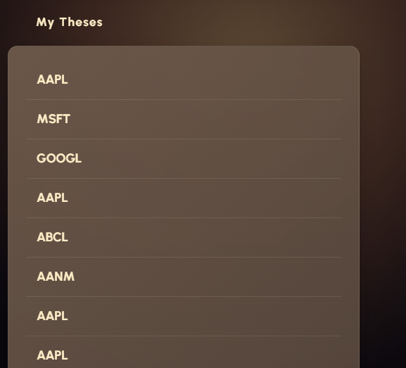 |  | 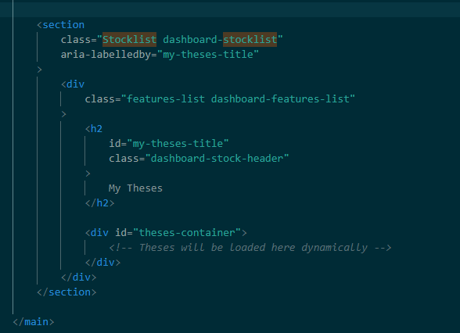  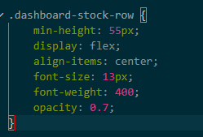  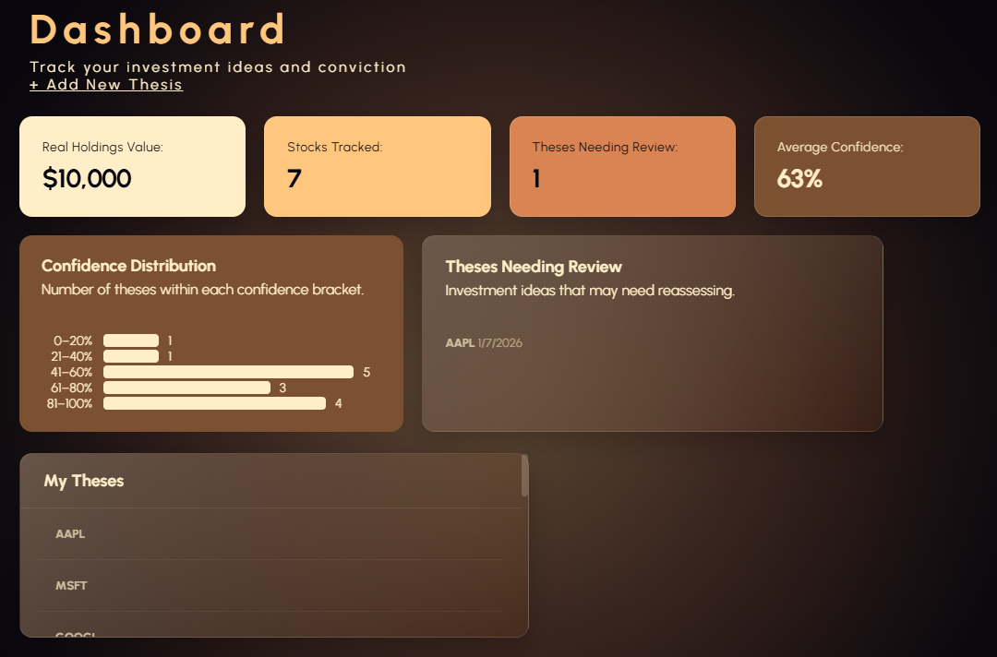  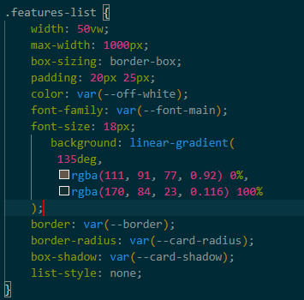 |  |  | Currently the my theses section styling doesn’t match the rest of the dashboard, looks a bit off, and the actual section height is too large. I want to restyle it and also add two fall backs, if the number of logged theses is 20 and below, use a scroll bar and if its above a search bar.  Changed the background to a nice gradient color like the theses needing review section, this helps indicate that these elements share a similar purpose too.  Updated the css for my dashboard-stock-row to be consistent with the rest of my widgets.  Shifted the theses title inside of the dashboard-features-list div to ensure that it gets styled as part of the background rather than separated, this also makes it more consistent with the rest of my design
24/08/26 | 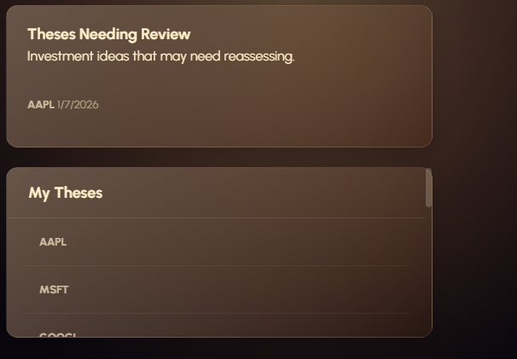 |  | 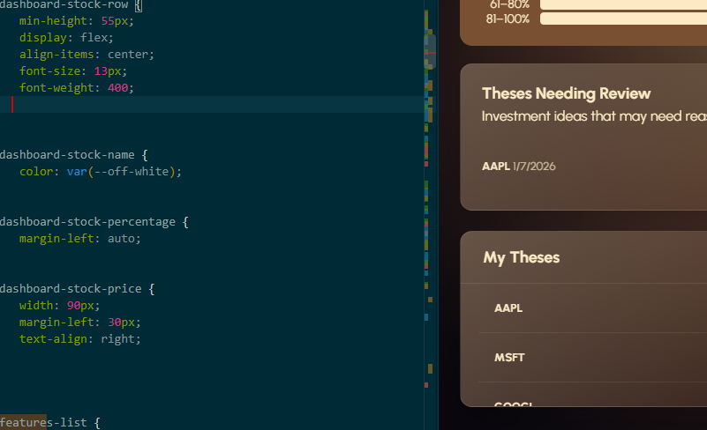 |  |  | While similar in design now I notice that its difficult to read the small theses. This is important as that’s the main function of my interface. I will fix this by removing the 0.7 opacity property from the css for both to ensure they are readable.
24/08/26 | 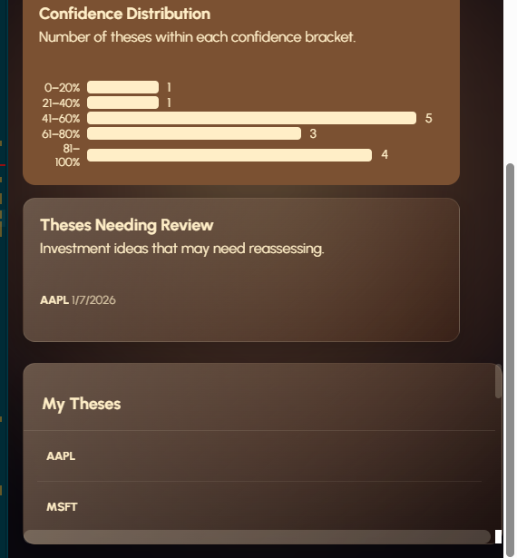 |  | 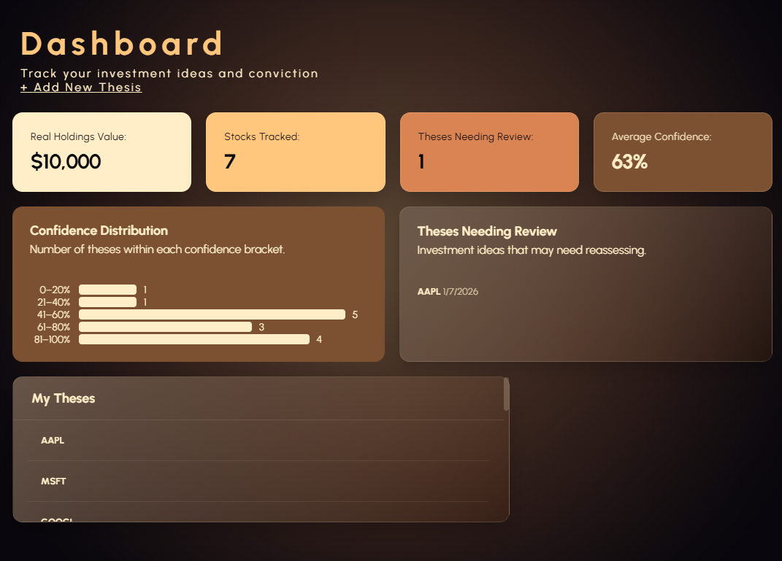 |  |  | Inconsistent use of flexbox. The my theses section does not have the small margin like the rest of my sections do when resizing the VW. I also notice that the top margin stays big while the margin between the two widgets above it resizes to be smaller.
29/08/26 |  |  |  |  |  | This element is a little bit confusing. This my theses section, where I go to access all of my theses of course. When trying to click on one of my saved thesis the whole box lightens when I hover my mouse over it, but only the text is clickable. This could be confusing because the user could end up clicking more than once, trying to find which part of the box is clickable.  The easy fix is to make the whole box clickable instead.
29/08/26 | 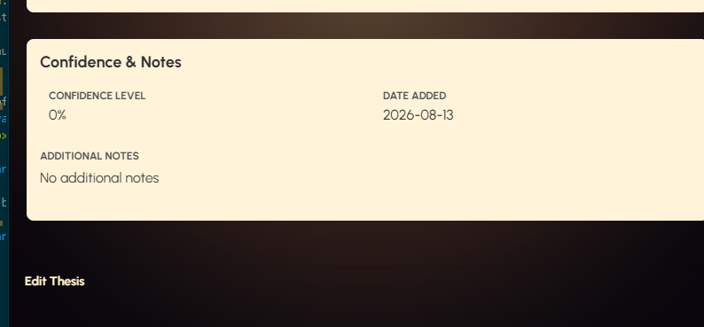 |  | 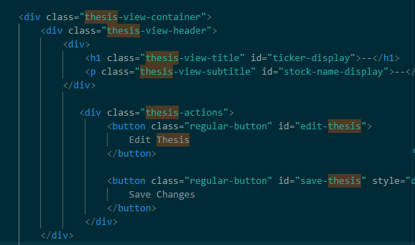    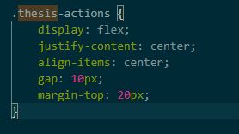 |  |  | Right now it’s weird having these buttons off to the left, and I also think they are in the wrong part of the page for their importance. The whole purpose of viewing theses again is to edit them, so why should the button to do so be tucked away at the bottom of the page where the user can’t see it.  Added flexbox to align the button to the centre of the screen, this works but I still don’t think it’s in the right place.  Moved them inside of the thesis-view-header. To be better positioned. Having them at the bottom made them feel disconnected from what they were actually controlling.
29/08/26 | DESKTOP / LARGE SCREEN TESTING and REFINEMENT  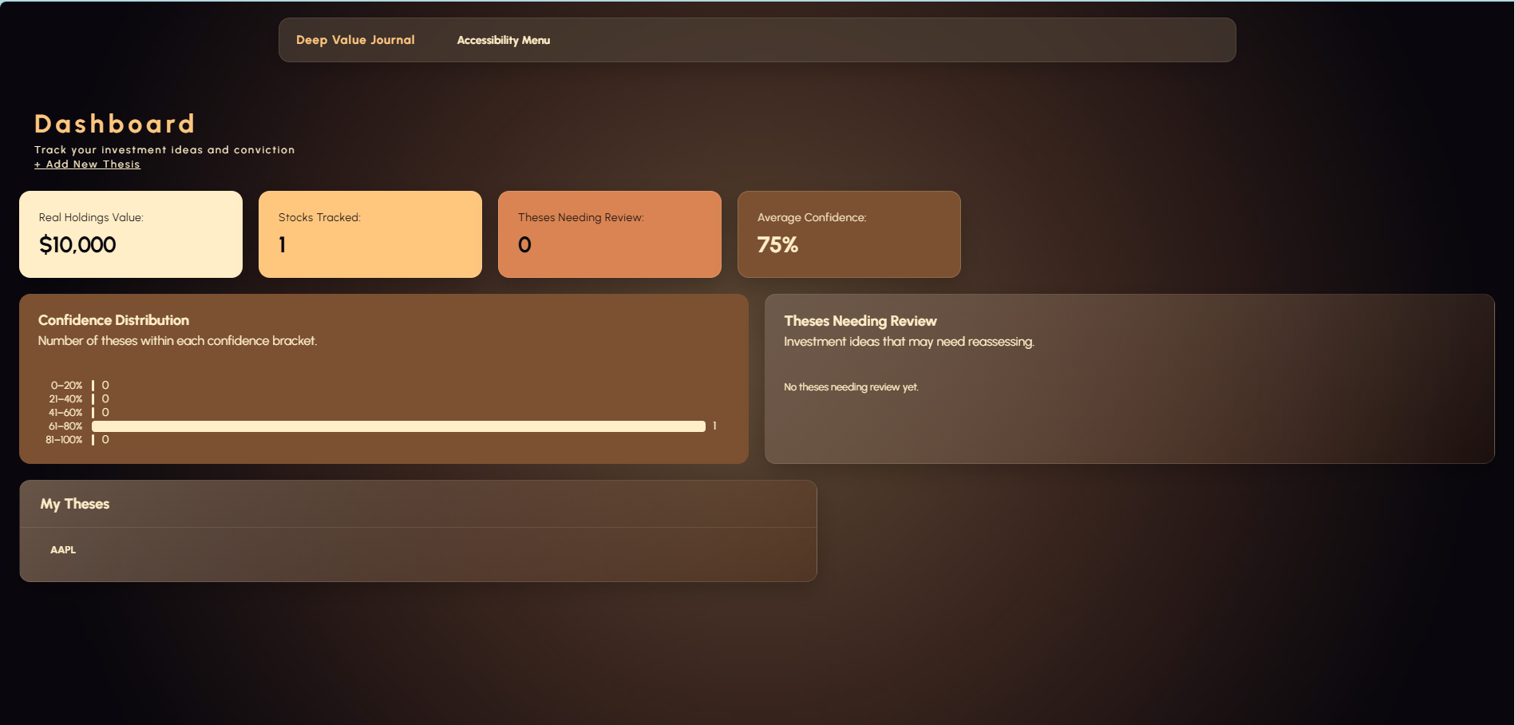  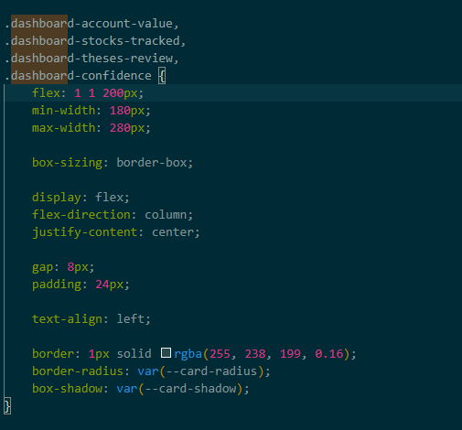  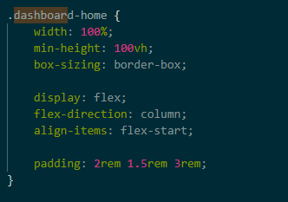 |  | 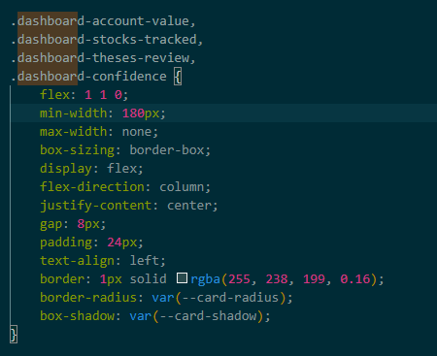  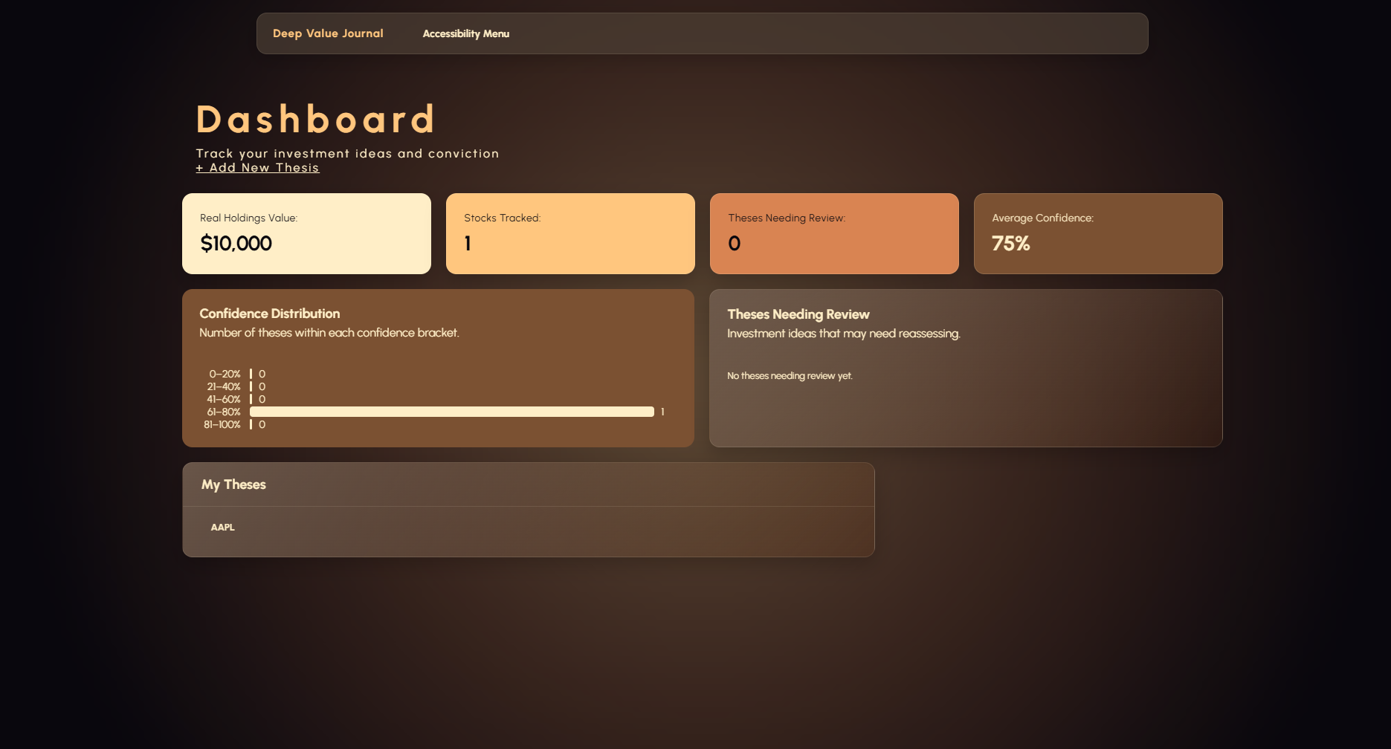  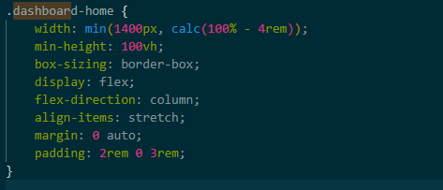 |  |  | I designed my interface using a lot of live preview. While it looks nicely proportioned on a live preview sized VW. It looks awkward on a full size computer screen.  The main issue is that on a large desktop, several elements stop growing while the overall page gets wider, ending up with lots of empty space.  Change 1:  Changed .dashboard-home { padding: 2rem 1.5rem 3rem; } to .dashboard-home { padding: 1.5rem 1rem 2.5rem; }  This reduces the space between the edge of the screen and my dashboard content, ensuring that whitespace around my elements isn’t too large  Change 2:  I originally had .dashboard-account-value, .dashboard-stocks-tracked, .dashboard-theses-review, .dashboard-confidence { flex: 1 1 200px; min-width: 180px; max-width: 280px; } but I changed it to have no max width. Before the maximum width of 280px meant that the card could flex, but on a large desktop screen there would be lots of empty space as the VW is much wider than 280x4. Having no max width means the elements can expand to fill up the available space
29/08/26 | 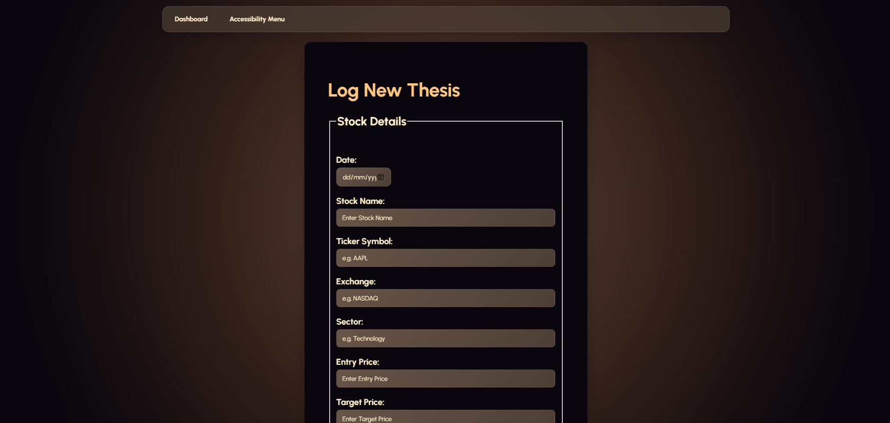  DESKTOP / LARGE SCREEN TESTING and REFINEMENT  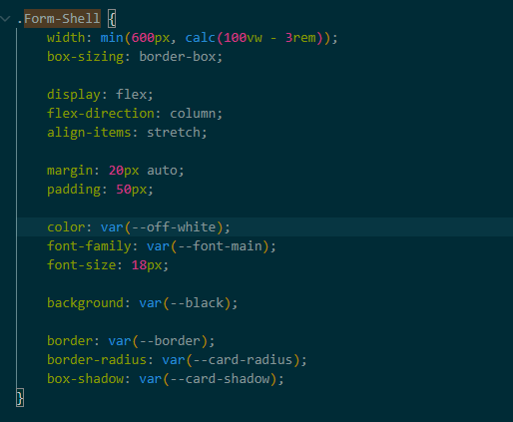  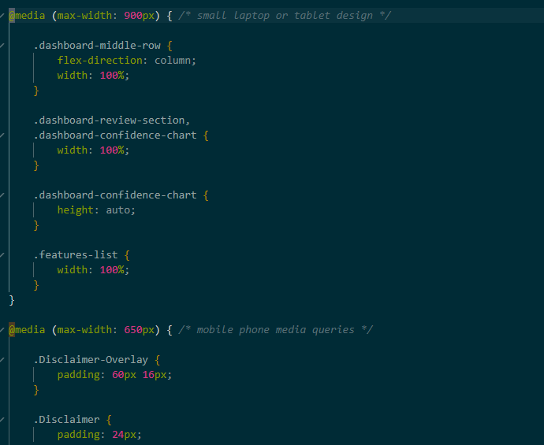 |  | 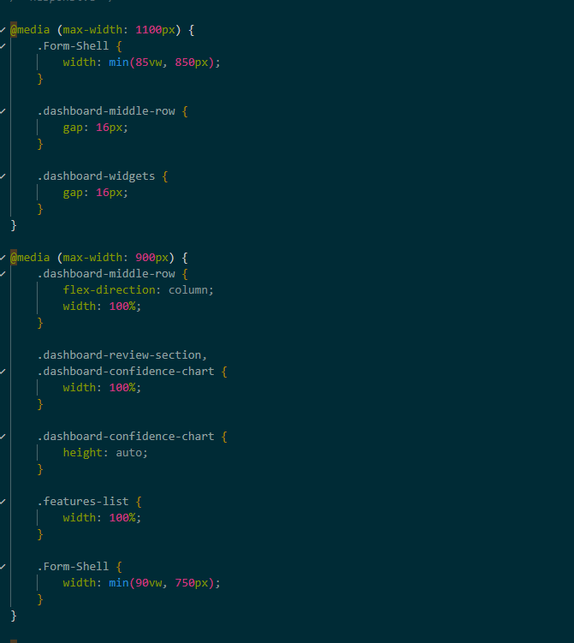  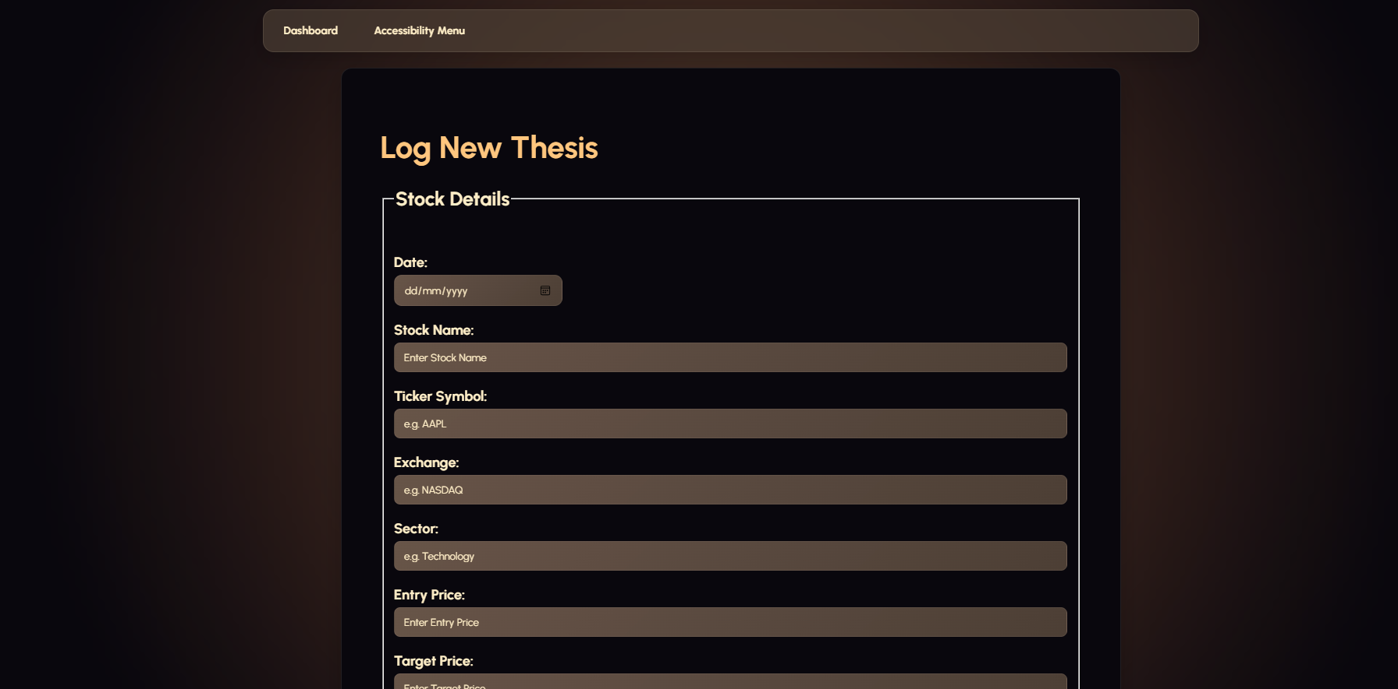  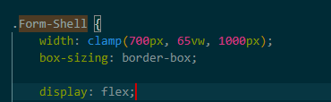 |  |  | I don’t like how narrow the log new thesis form is on a large desktop screen.  Development log:  Change 1:  Increased the width of the thesis form  From width: min(600px, calc(100vw - 3rem));  To width: clamp(700px, 65vw, 1000px);  Rationale: the original 600px maximum made the thesis form feel far too narrow on laptop screens, which left lots of whitespace around it.  The new clamp() value ensures the form feels fluid and responsive. Growing with the viewport while staying between 700 and 1000px.  Change 2:  Added more media queries breakpoints  Before the stylesheet used 900 and 650px breakpoints. I added a 1100px breakpoint.  A single breakpoint doesn’t cover the large range between desktop, laptop, tablet and mobile screen sizes. I need to have inbetween sizes to ensure the interface is appealing.  The interface now has more gradual transitions between screen sizes, which makes it feel more appropriately sized.
29/08/26 | 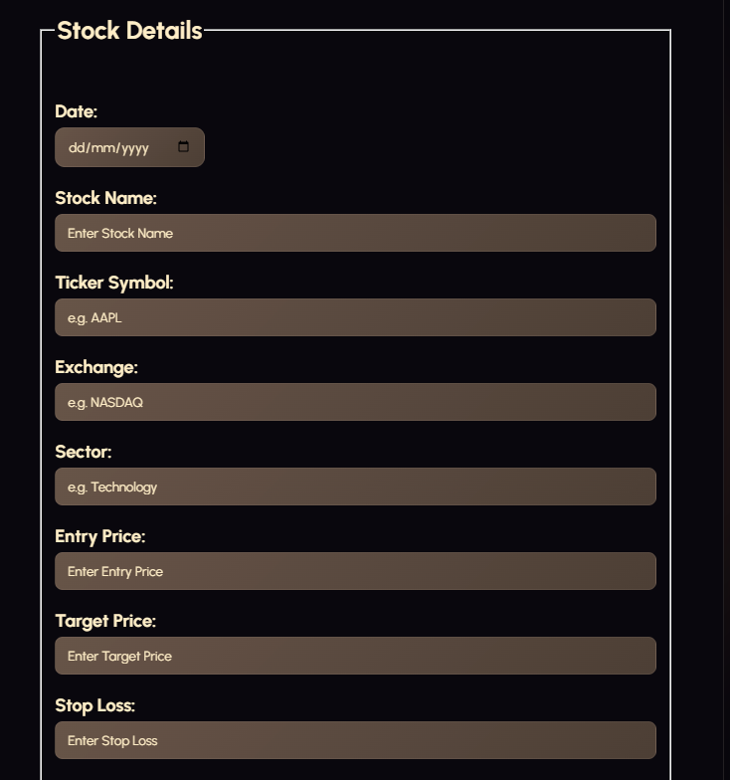 |  | 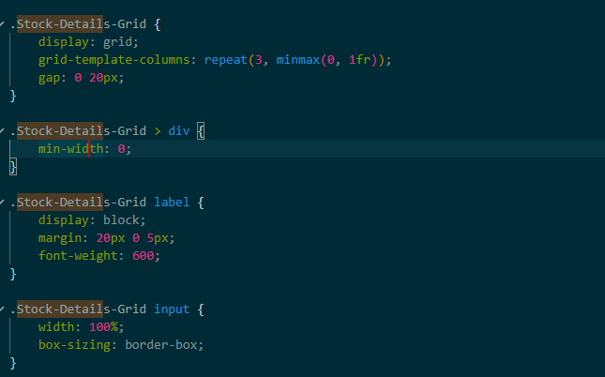  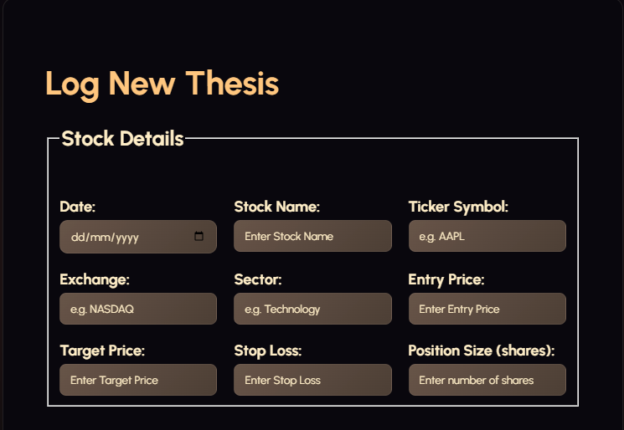  consolidated design  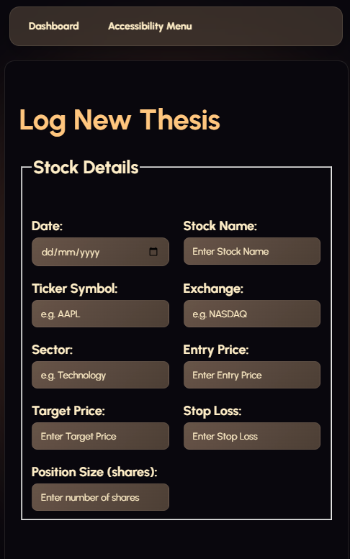  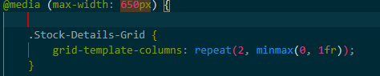 |  |  | i feel like everything in the stock details part of the form could be consolidated into a grid. You only really need to enter single numbers or words for it, they don't need a 700 - 1000px line each.  Added a responsive stock details layout.  - Changed from a single vertical list to a CSS grid.  Placed the stock details fields within a grid container, creating 3 equal columns as the default.  I then added a mobile media query to change the grid to two columns. This means that if the VW is less that 650px, the 3 columns goes down to two, ensuring that all the categories are still visible nicely, for a more responsive design.
30/08/26 | 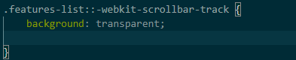  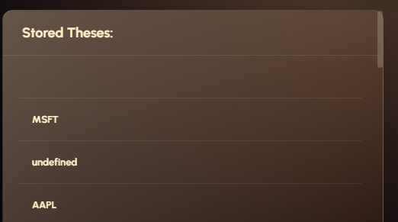 |  | 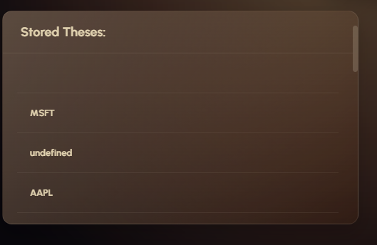  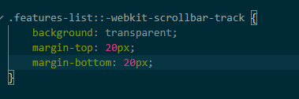 |  |  | Visual Refinement:  The scroll bar currently sits a little bit too high in the top position, meaning that it sticks out above the curved border of the stored theses section.  Gave the scroll bar track a top and a bottom margin to stop the scrollbar thumb from going past the border.
30/08 | 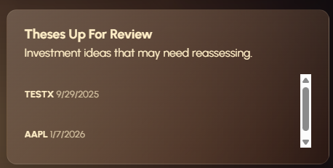 |  | 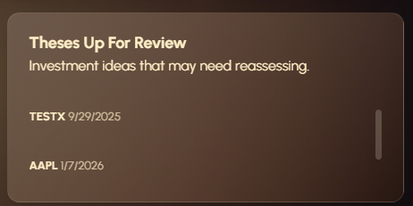  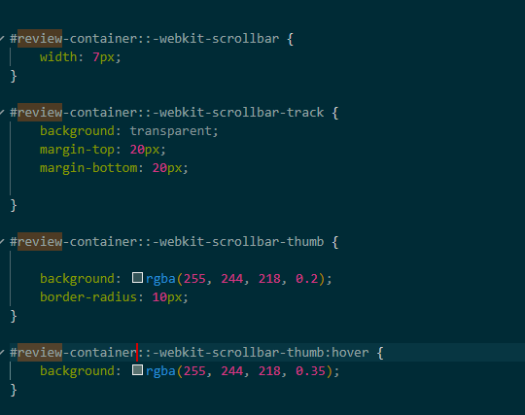 |  |  | The scroll bar for the theses up for review section isn’t styled. I can fix this by adding a webkit-scroll bar element just like I did for the features list.
30/08 |   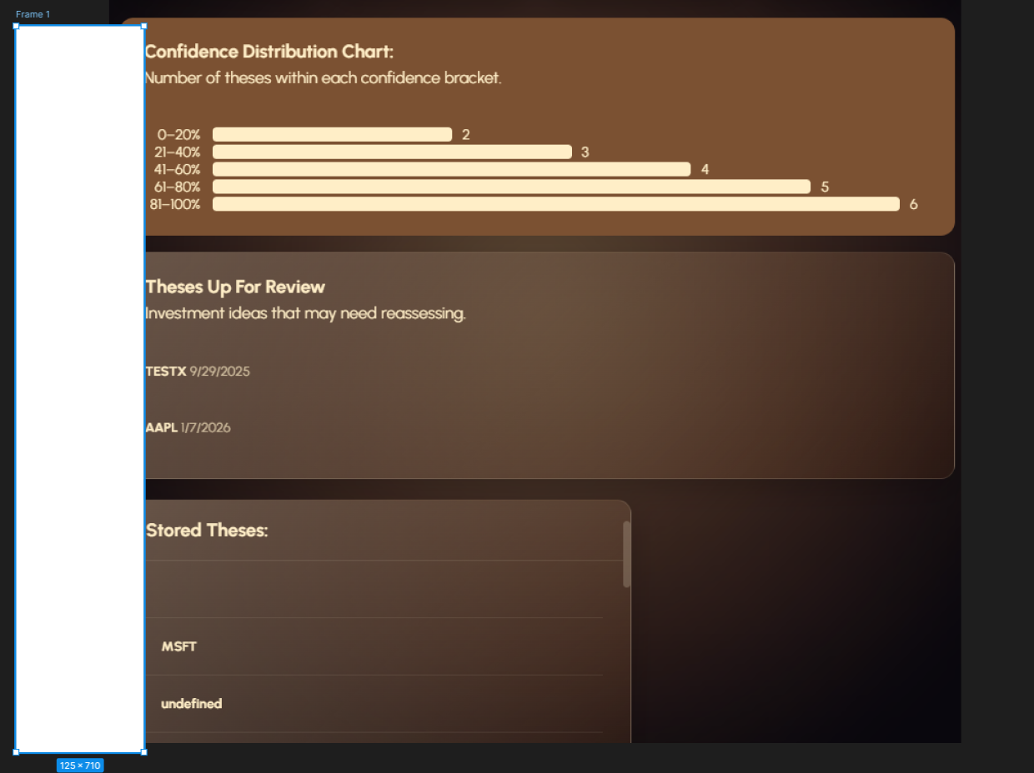 |  | 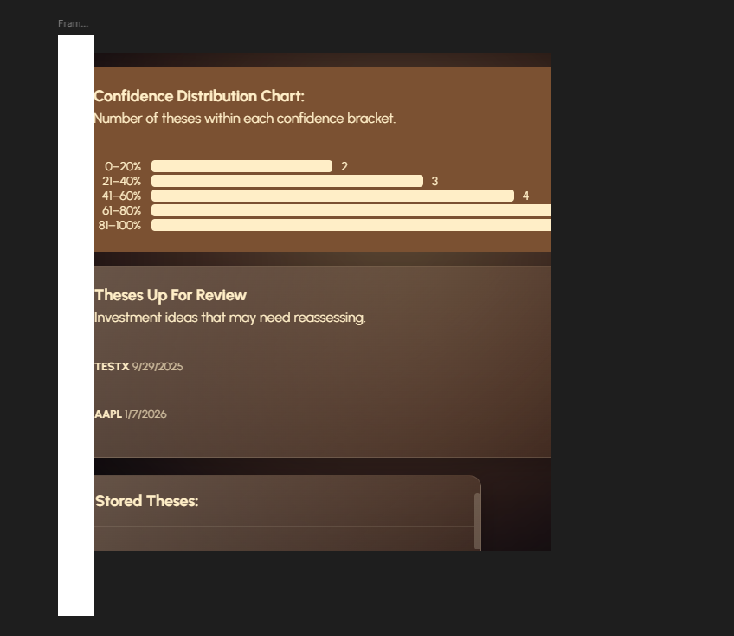  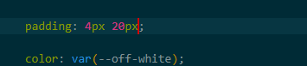 |  |  | Refinement to make my interface more consistent  Problem: padding around the heading isn’t quite equal for all elements of my dashboard.  Adding universal padding for my dashboard widgets to ensure a familiar feeling interface.  Changed the padding for the features list section from 0 20 12 to 4 20. To validified that I lined it up using figma. This improves the interface because it makes it more consistent
30/08 | 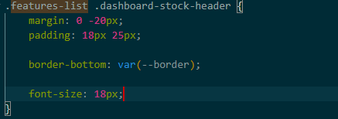  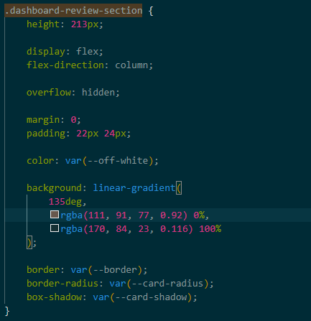  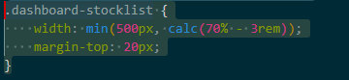  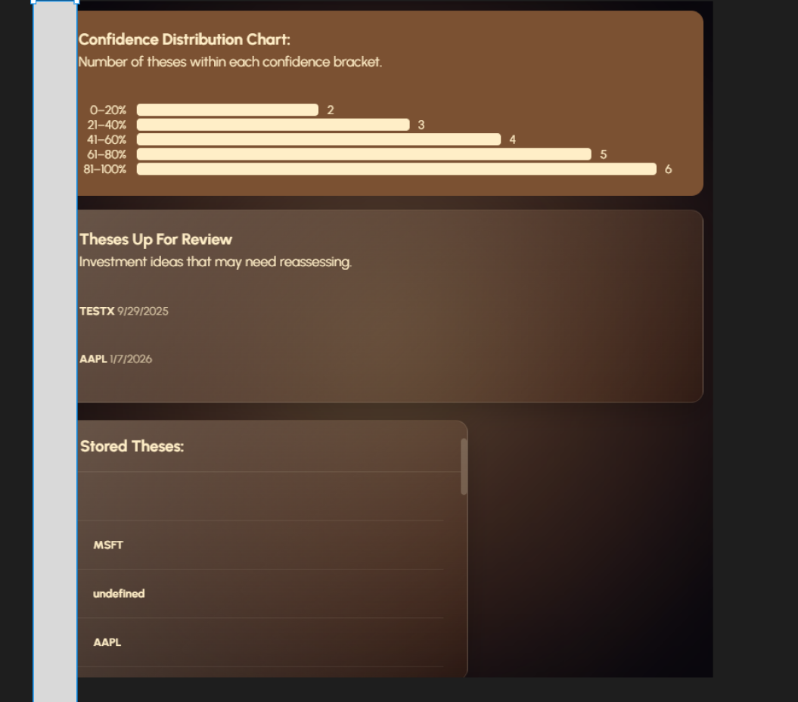 |  | 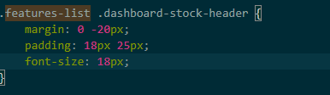  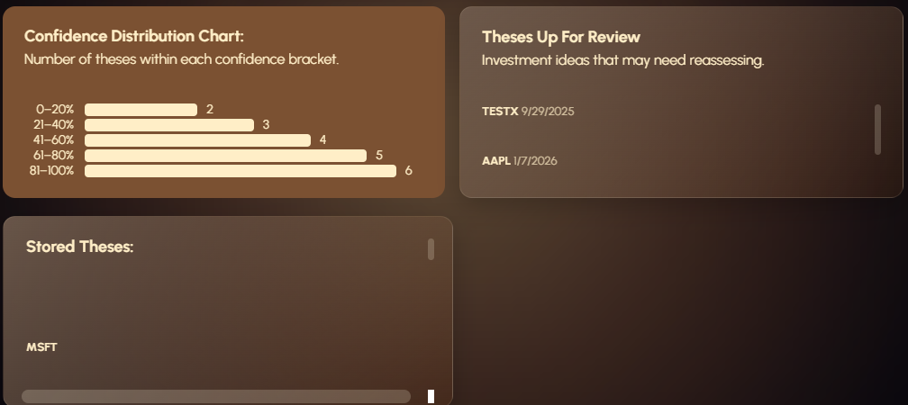  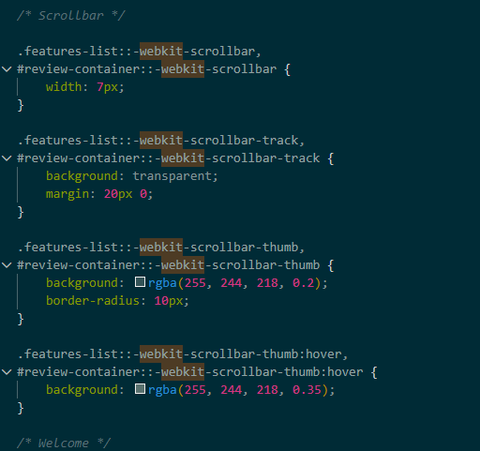  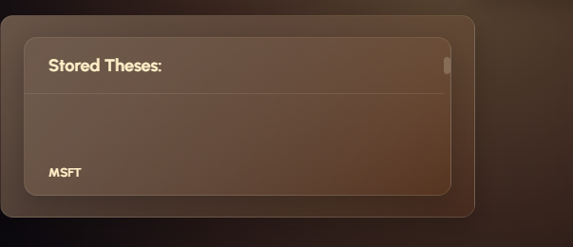  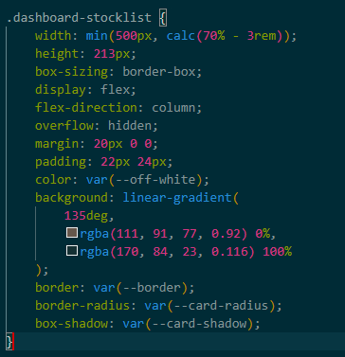  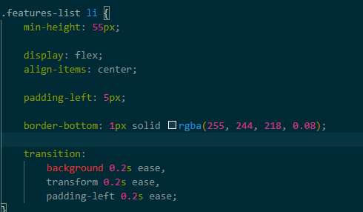  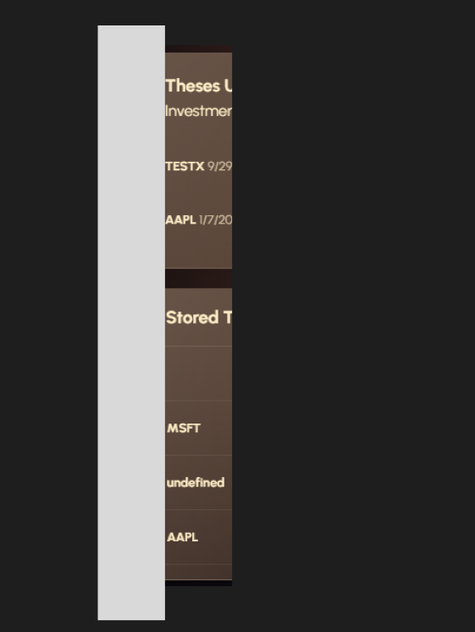 |  |  | Elements within the three large dashboard sections are not lined up. This leads to an inconsistent looking interface, which is bad  Changelog:  Updated the left margin for the features-list to be 5 px from 20px, to line up the elements correctly, allowing for a more consistent interface.  Styled theses up for review and stored theses to look the same with consistent padding and typography and consistent designs  I universalised the scroll bar for them through webkit to both reduce unnecessary css and make them look the same.  The sections are now more unified and polished aesthetic wise.
 | 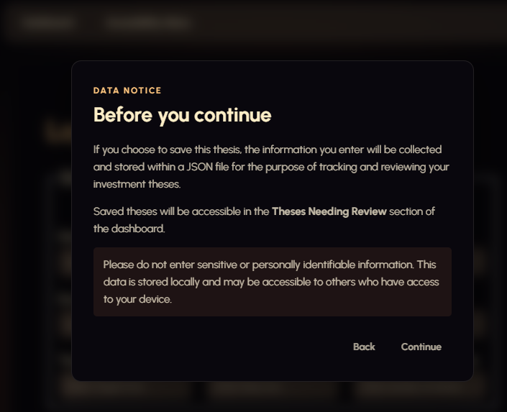  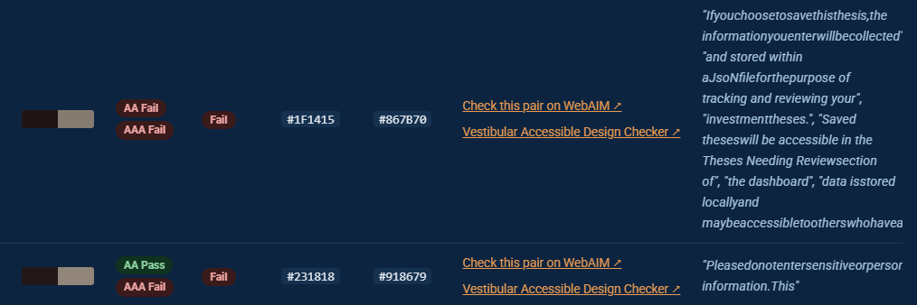  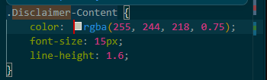    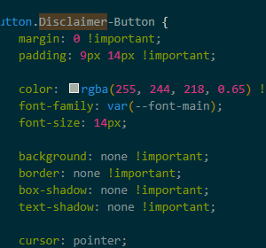 |  | 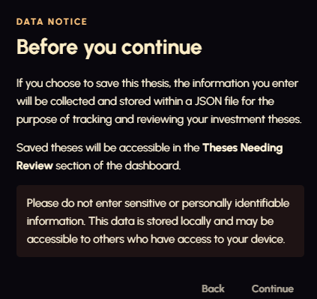  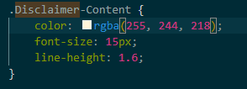    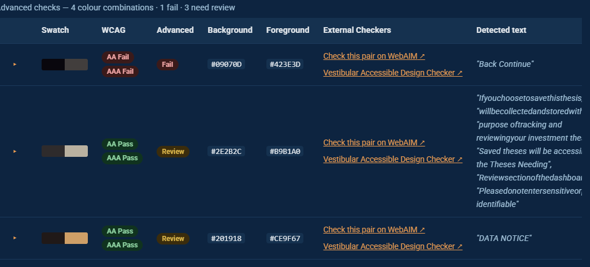 |  |  | Testing based off of Nikhils feedback that my contrast on my disclaimer might be too low.  The contrast checking website tells me the contrast between the first part of text starting with ‘if you choose to save this thesis’ and the second blurb ‘please do not enter personal data’  Fail the contrast checker.  Changes made:  Disclaimer-content css  Colour has an opacity of 0.75, this makes the contrast too small.  I removed from the opacity property from the RGB colour so that its not lighter than it should be, improving the contrast.  I inserted a new picture of the updated contrast disclaimer back into the contrast checker.  Its not telling me that the actual disclaimer-content has strong contrast and passes the contrast checker.  However its now flagging the buttons as failing the contrast checker, as they are still the same colour as the old disclaimer-content css.  Button.Disclaimer-button still actually has the colour of the button text still set to 0.65 opacity which is even poorer than the original content was.  I removed the opacity property from the colour and the contrast has improved a lot visually, but I will check it one more time with the contrast checker to verify.  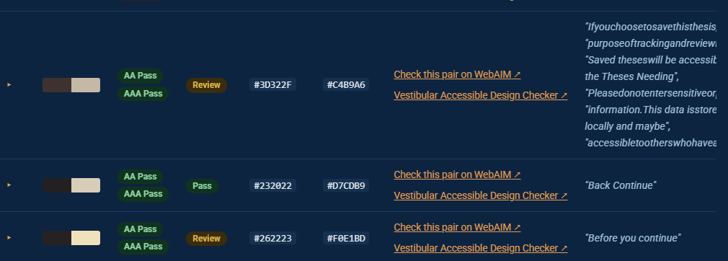  Buttons and text all pass the contrast checker now
4/09/26 | 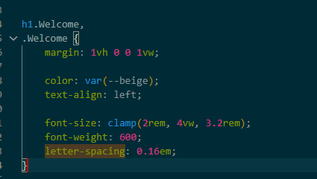  Initial: |  |   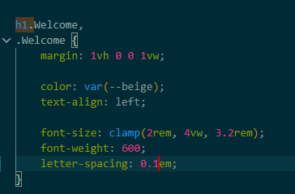 |  |  | Feedback improvements:  According to my reviewers the letter spacing on the dashboard title is too large to be aptly readable. This is important because it defines the purpose of the interface.  Decreased the letter spacing from 0.16 to 0.1em, and then got my reviewer Nikhil to retest my interface and see if he liked my changes.  See log on the 4th of September in the early stage feedback table
4/09/26 | 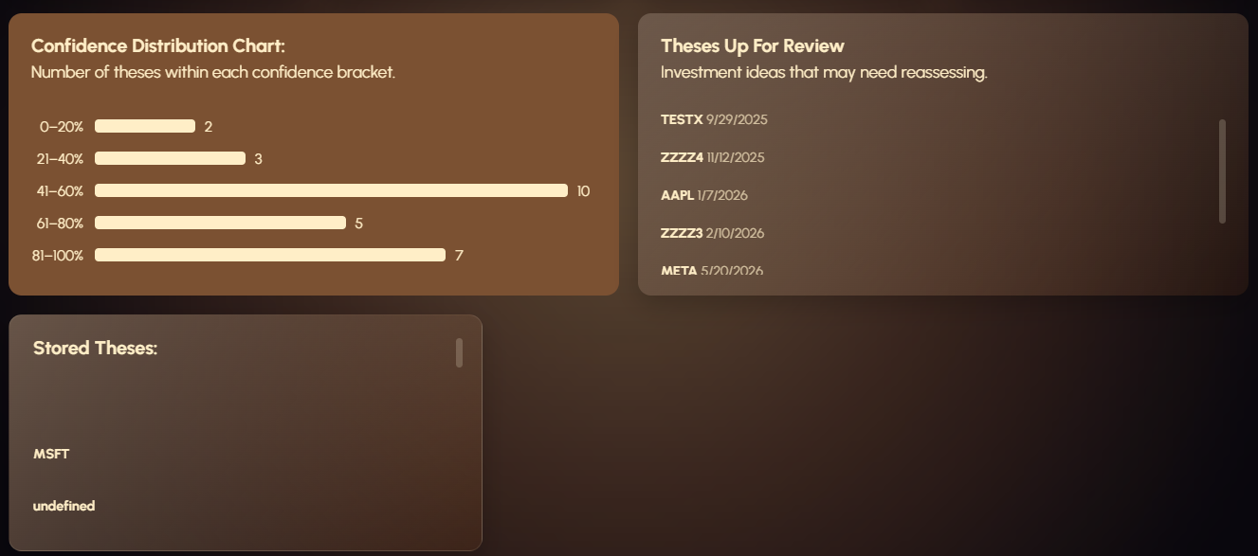  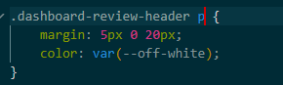  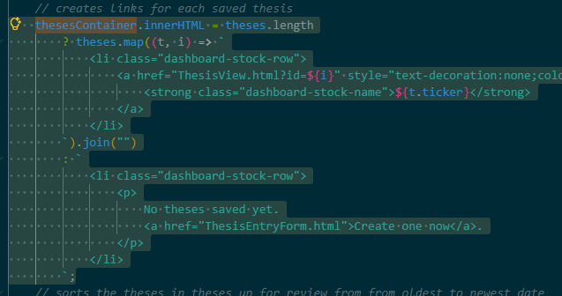  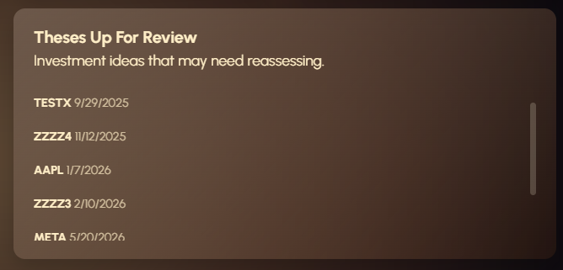  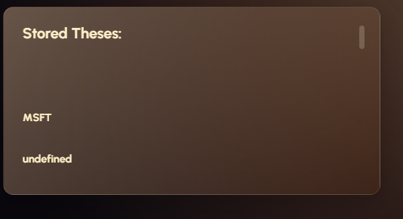 |  | 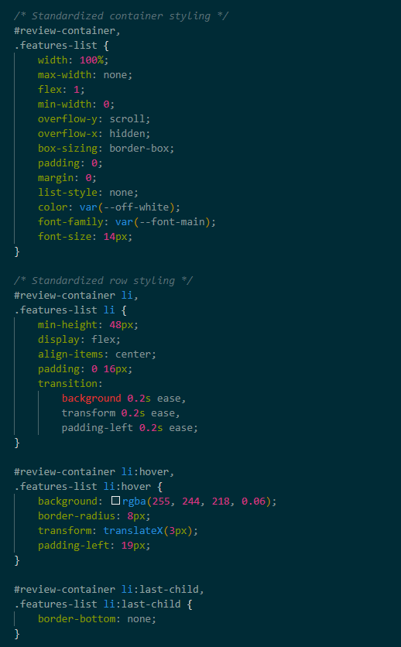  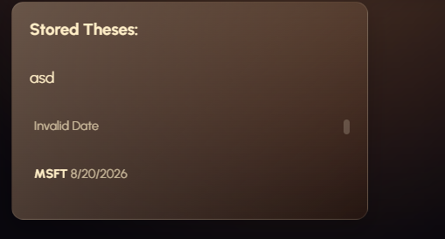  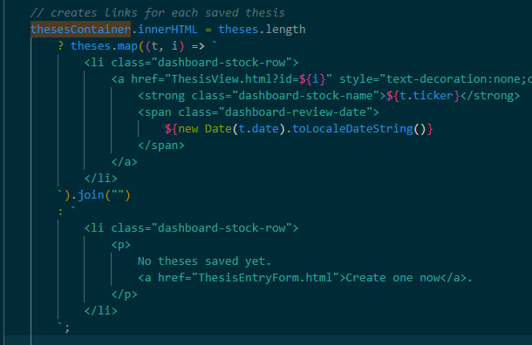  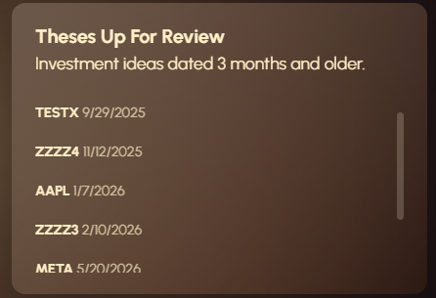 | Visual refinement to make my interface more consistent  I have previously tried to standardize the styling on both my theses up for review and stored theses boxes, but currently I’m noticing a few issues.  Issues:  - Spacing between rows in the stored theses section is greater than that in theses up for Review.  - Theses storage has no dates next to the theses, whereas theses up for review does  - Stored theses needs a small subtitle like theses up for review has explaining its purpose.  - Theses up for review needs a more descriptive title.  Changelog:  - Combined dashboard-review-header – with additional styles for the <p> element I added to the stocklist, ensuring they have the same styling  - Standardised the container styling of review-container and features-list. This eliminated nearly identical css rules for review-container and features-list. It also helps ensure visual consistency as both containers have the same scroll behaviour. Overflow-y: scroll and overflow-x: hidden. The same sizing rules with flex:1 the same spacing with padding and margin 0. Similarly it helps maintain a responsive design by using more flexbox, and allowing the flex items to shrink below their content width to prevent overflow using min-width: 0  - Added a span with the thesis date to each stored thesis row using javascript in the thesesContainer.innerHtml property. New Date(t.date) converts the stored date string into a javascript object, toLocalDateString() formats the string into a readable date.  Debug:  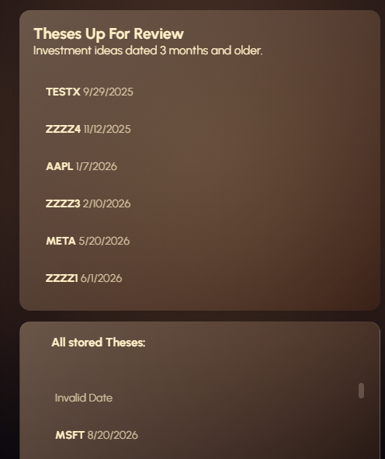  The header all stored theses has ended up smaller in font size than the theses up for review.  To fix this ill add a rule specifically targeting the h2 element of dashboard-stocklist  .dashboard-stocklist h2 {  font-size: 18px;  }  Problem solved:  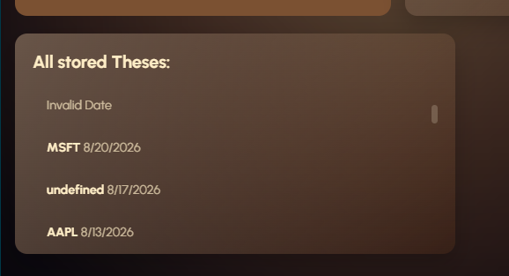
4/09/26 | 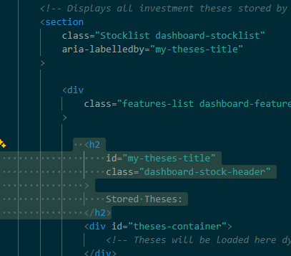  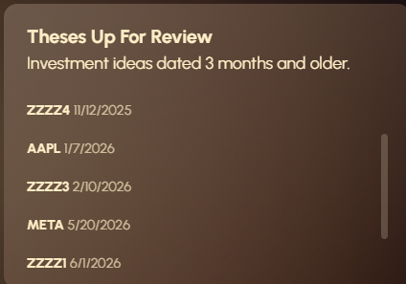  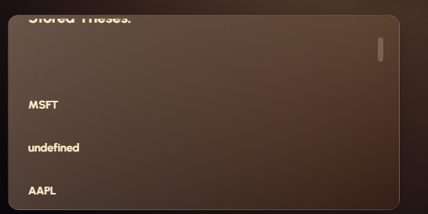 |  | 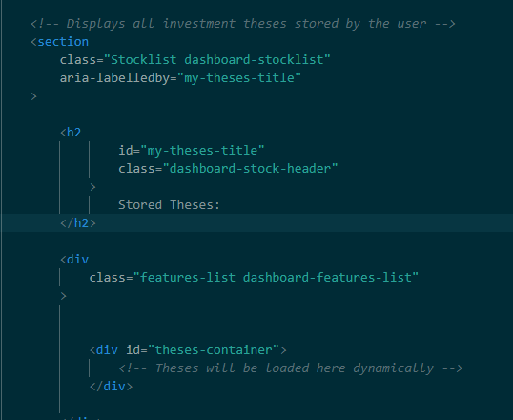  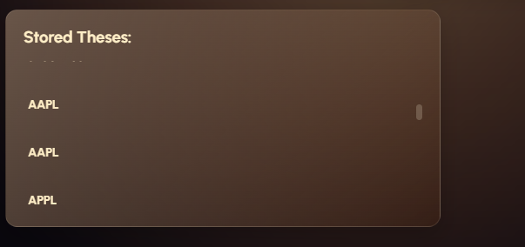 |  | Visual refinement for a more consistent interface. This is quite an important refinement so I thought it deserved its own row.  When scrolling through the list on both the stored theses and the theses up for review tabs I notice that the title is in a fixed position for the theses up for review section but not on the stored theses. This means that the title disappears when the user is trying to scroll through their list of theses, leaving the tab unidentifiable. It also has the other effect of making the title seem like its another thesis in the list, hence it needs proper fixed in place behaviour so that it acts like a title.  Change:  Moved the H2 title above the dashboard features list instead of it being below it before. This means it doesn’t scroll with the actual stored ideas anymore.
4/09/26 |  |  |  |  | Improvements based on feedback: adding a sticky navigation bar.

Code optimization + testing:
- I’m testing whether my HTML and CSS are ‘validated, tidy code; explain any deliberate exceptions to W3C advice.’ + avoid unnecessary repetition
CSS VALIDATION AND CHANGES | CSS VALIDATION AND CHANGES | CSS VALIDATION AND CHANGES | CSS VALIDATION AND CHANGES
Date | Before Image | After Image | Explanation
22/08/26 | 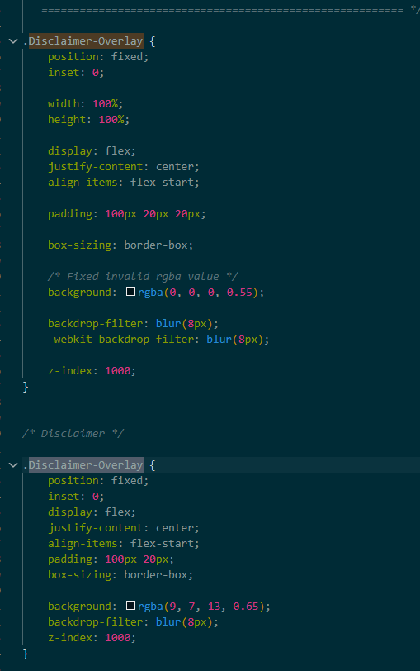 | 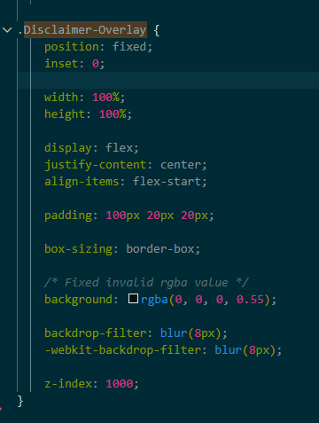  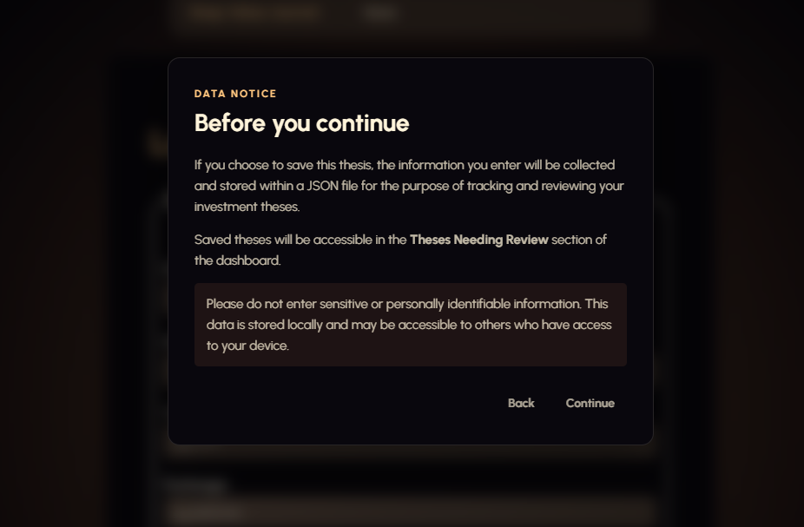 | Disclaimer-overlay section is repeated twice, with many overlapping variables. I can combine it into one section to simply my code and reduce repetition.  I checked the visual output to ensure that nothing has changed to the visual appearance of my disclaimer, and it hasn’t so validation has been successful here.
22/08/26 | 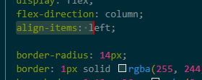 |  | Align-items: left is not a valid align-items value, hence I need to change it to flex-start; to make it valid
22/08/26 |  | 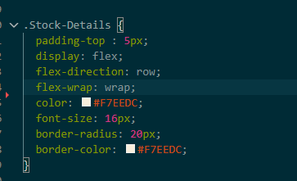 | Useless grid property: Because .stock-details is display:flex; grid-template-columns does nothing. I will delete it.
22/08/26 | 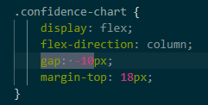 | 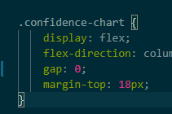 | Negative values for the gap property are invalid. I changed this to gap: 0;
22/08/26 |  | 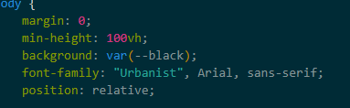  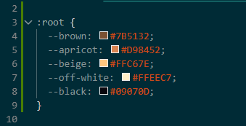 | I created custom CSS properties called global variables. I use these for colors instead of typing out the complicated hex codes to prevent inconsistent or incorrect color values throughout my CSS.
22/08/26 | 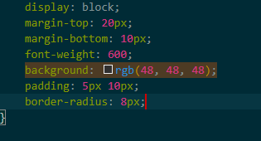 | 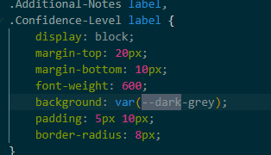  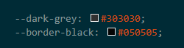 | Adding additional root variables to get rid of some repeated RGB color codes throughout my code.
22/08/26 | 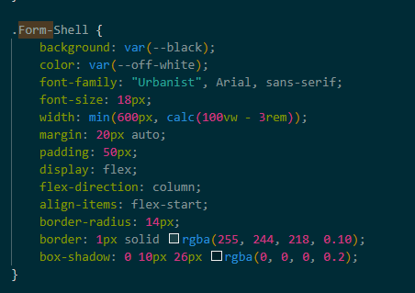 | 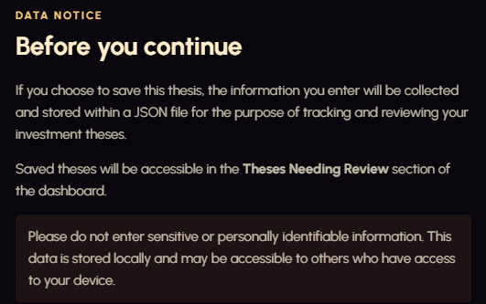  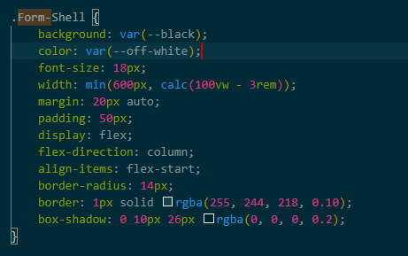 | My code has lots of repetitions of font-family: "Urbanist", Arial, sans-serif. I have it under the body{ } so most normal elements inherit the front anyway. I can optimize this by just deleting the font from those elements where its not required.  I checked all of my HTML to ensure that all of the divs and text elements actually lie inside the body, and they so, hence its not going to affect anything getting rid of the fonts for the divs inside.  Validation that the text still looks the same after I removed it from many elements and it did. The only one I didn’t do it for was the buttons because its deliberately there to overwrite the global button font.
22/08/26 | 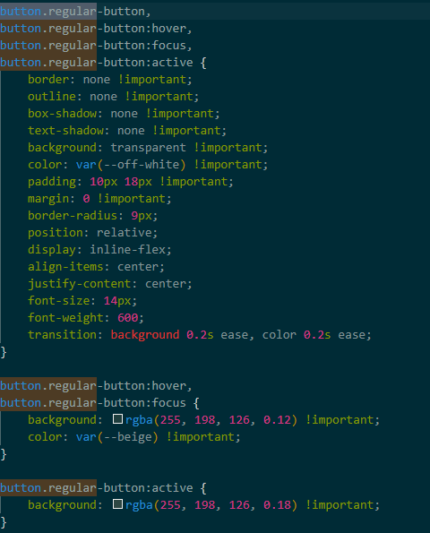 | 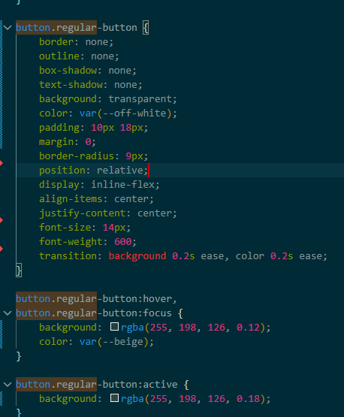 | Issue: excessive use of important in button styling. Global button selector applies website’s default button design, navigation buttons require different styling.  Change made: removing the important tags from the .regular-button, and .Disclaimer-button rules.  More specific selectors button.regular-button and button.Disclaimer-Button used to override global button styling.  How come this change still overrides the global button for button.regular-button?  Button has a specificity of 0,0,0,1. Button.regular-button has a specificity of 0,0,1,1 meaning it is more specific than generic button selector.  The browser knows it’s a button, but recognizes it’s specifically a regular-button so it uses the more specific CSS.  Exactly the same thing done for the disclaimer buttons  This reduced the unnecessary use of important tags which makes the CSS easier to maintain because there’s not a bunch of overwrites.
HTML VALIDATION AND CHANGES | HTML VALIDATION AND CHANGES:  Showing results for contents of text-input area (checked with vnu 26.8.24) - Nu Html Checker  VALIDATION FOR JOURNALHOME.HTML | HTML VALIDATION AND CHANGES | HTML VALIDATION AND CHANGES
Date | Before Image | After Image | Explanation
25/08/26 | 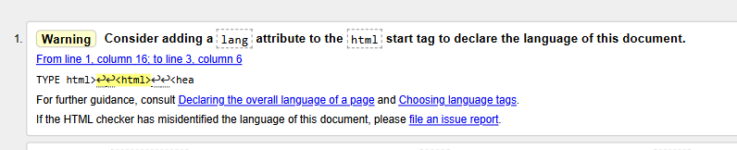 |  | 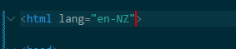
25/08/26 | 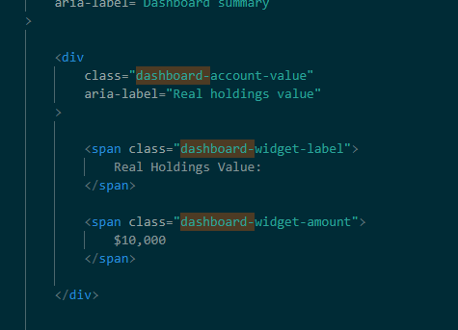  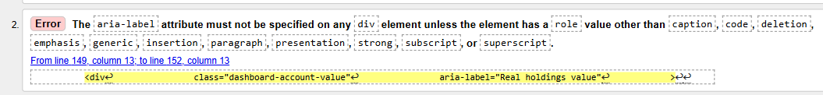 | 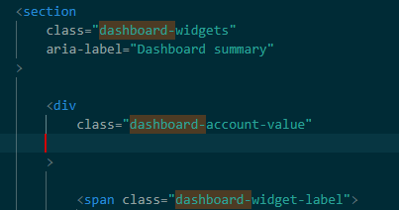 | Issue: I was using an aria-label attribute on a <div> but <div> elements cannot use aria-label without an appropriate ARIA role.  Fix: I removed the unnecessary aria-label because the div already contains visible text describing the content. This makes the HTML valid while still providing the same information to users and screen readers.
25/08/26 | 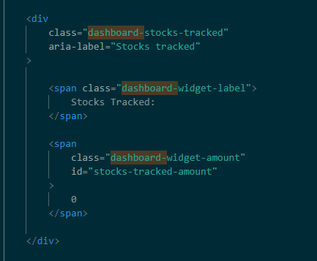  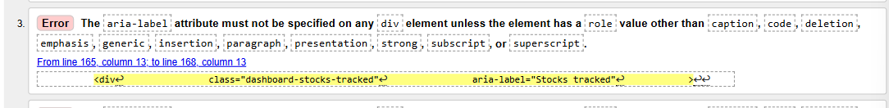 | 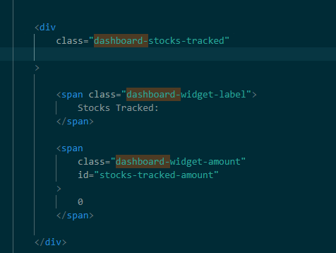 | Issue: I was using an aria-label attribute on a <div> but <div> elements cannot use aria-label without an appropriate ARIA role.  Fix: I removed the unnecessary aria-label because the div already contains visible text describing the content. This makes the HTML valid while still providing the same information to users and screen readers.
25/08/26 | 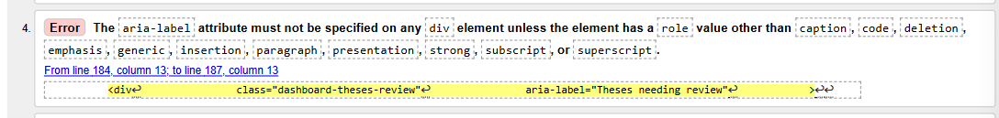  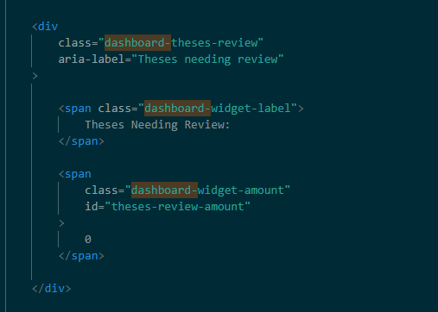 | 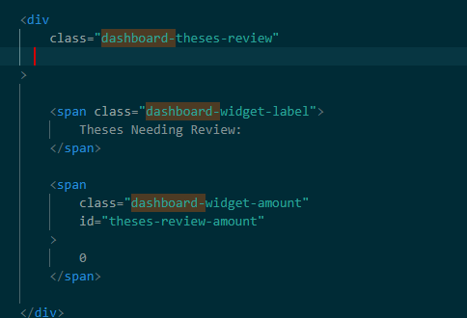 | Issue: I was using an aria-label attribute on a <div> but <div> elements cannot use aria-label without an appropriate ARIA role.  Fix: I removed the unnecessary aria-label because the div already contains visible text describing the content. This makes the HTML valid while still providing the same information to users and screen readers.
25/08/26 | 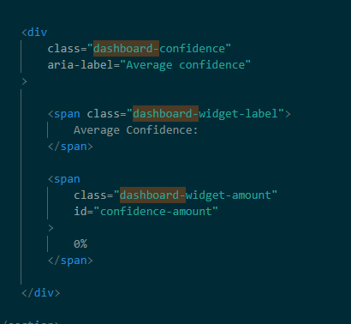  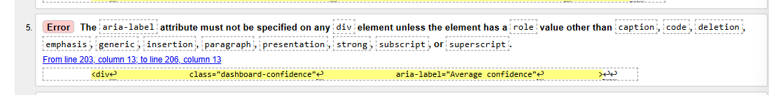 | 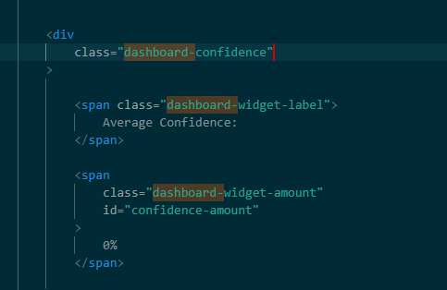 | Issue: I was using an aria-label attribute on a <div> but <div> elements cannot use aria-label without an appropriate ARIA role.  Fix: I removed the unnecessary aria-label because the div already contains visible text describing the content. This makes the HTML valid while still providing the same information to users and screen readers.
25/08/26 | 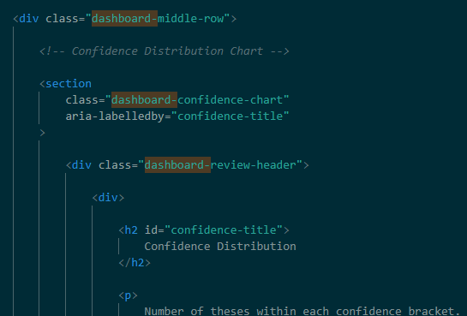  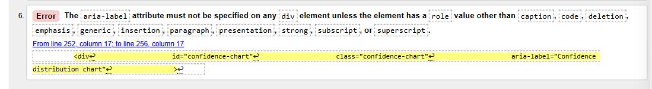 | 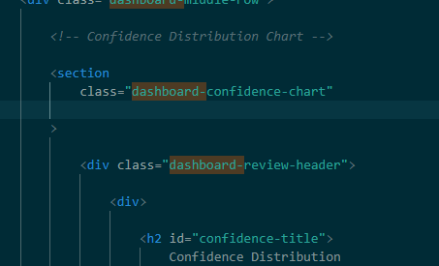 | Issue: I was using an aria-label attribute on a <div> but <div> elements cannot use aria-label without an appropriate ARIA role.  Fix: I removed the unnecessary aria-label because the div already contains visible text describing the content. This makes the HTML valid while still providing the same information to users and screen readers.
26/08/26 |   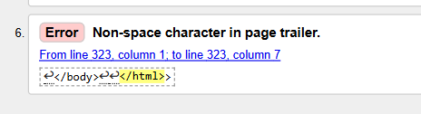 | 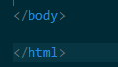 | Issue: There is an extra > after the closing </html> tag.  This fixes the error because </html> should be the final element in the document, with no additional characters after it.
26/08/26 | 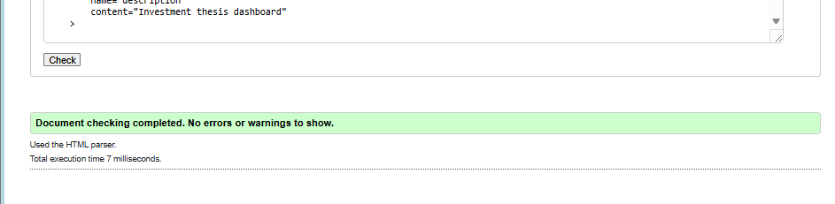 | Code validation of HTML for ‘Journalhome.html’  Final check complete, fully validated
 | CODE VALIDATION FOR ‘THESIS ENTRY FORM.HTML’
26/08/26 | 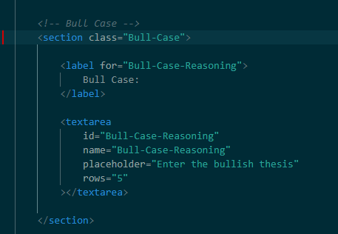  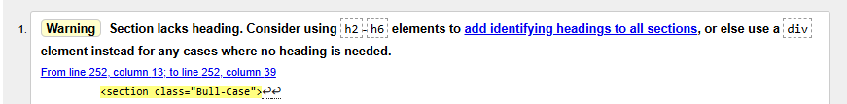 | 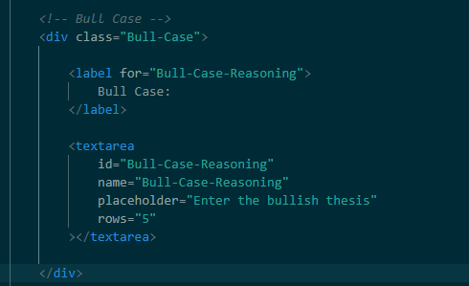 | Issue: The <section> elements are being used as containers, but they don't have a heading to identify what each section contains.  Fix: Since these are just containers and don't need their own headings, so i changed <section> to <div>
26/08/26 | 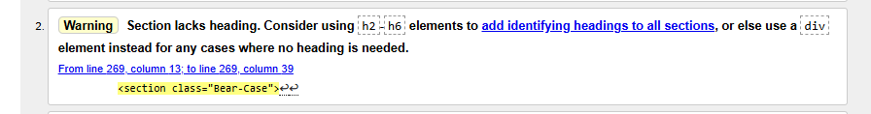 | 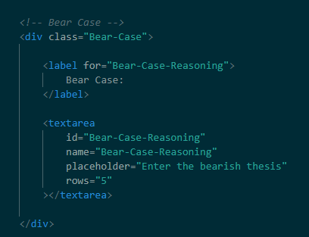 | Issue: The <section> elements are being used as containers, but they don't have a heading to identify what each section contains.  Fix: Since these are just containers and don't need their own headings, so i changed <section> to <div>
26/08/26 | 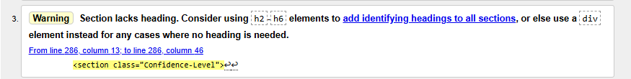 | 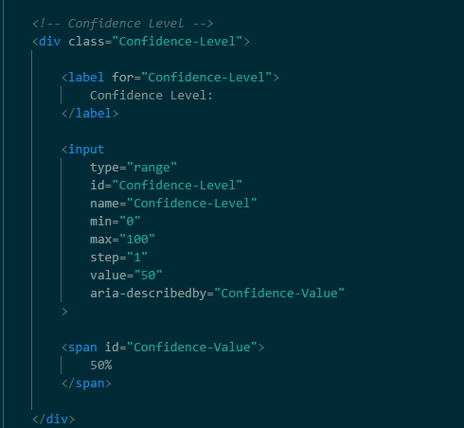 | Issue: The <section> elements are being used as containers, but they don't have a heading to identify what each section contains.  Fix: Since these are just containers and don't need their own headings, so i changed <section> to <div>
26/08/26 | 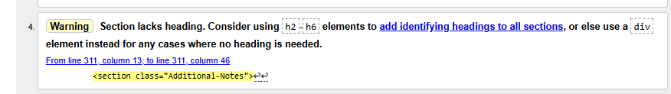 | 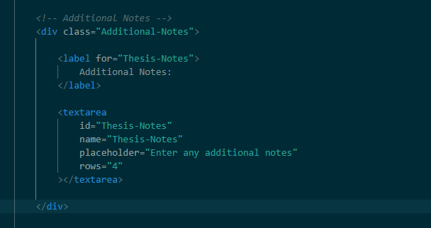 | Issue: The <section> elements are being used as containers, but they don't have a heading to identify what each section contains.  Fix: Since these are just containers and don't need their own headings, so i changed <section> to <div>
 | 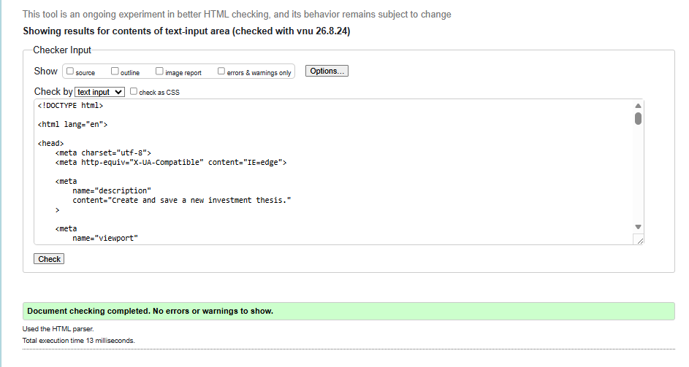 | Code validation of HTML for ‘Thesisentryform.html’  Final check complete, fully validated
 | CODE VALIDATION FOR ‘JOURNALLANDING.HTML’
26/08/26 | 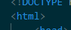  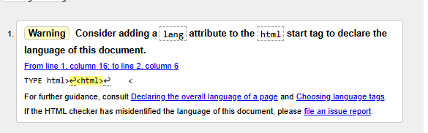 | 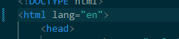 | Issue: the validator is saying that my html tag doesn’t specify the language of my page.  Fix: added lang=’en’ to the html tag at the start of my document to sell browsers, screen readers and accessibility tools that the page’s primary language is English.
 | 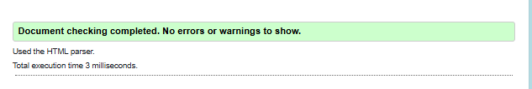 | Code validation of HTML for ‘JournalLanding.html’  Final check complete, fully validated
 | CODE VALIDATION FOR ‘ThesisView.HTML’
 | 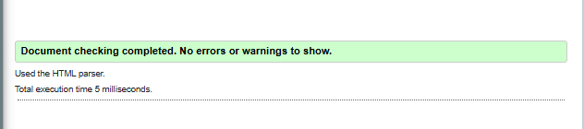 | Code validation of HTML for ‘JournalLanding.html’  Final check complete, fully validated, no issues to begin with.
 | CODE VALIDATION FOR ‘Journal.js’
 |  |  | Not really sure what’s wrong here,
31/08/26 | 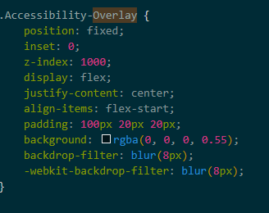  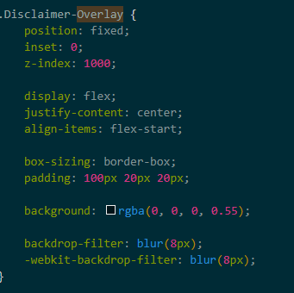 | 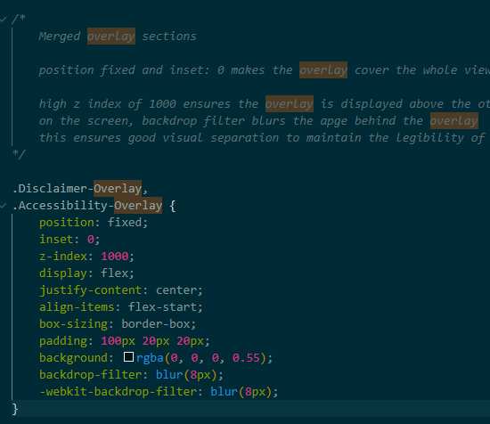 | Code optimization to ensure a more simplistic stylesheet, removing repeated elements:  Disclaimer-overlay and accessibility overlay have essentially the same thing for css properties. Merged the two proerpties into one to keep my stylesheet simplistic.  This improves my stylesheet because it keeps the same visual styling and improves maintainability and prevents accidental conflicts.  This also makes for a more visually consistent interface.
29/08/26 | 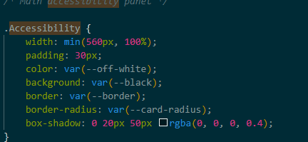  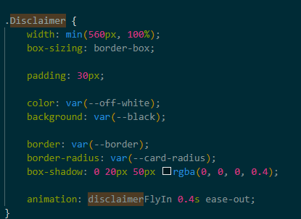 | 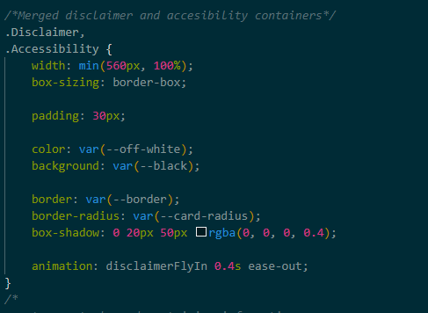 | These two sections also have essentially the same styling. So I will merge them

What my code validation improved:
I was able to go through my code and ensure that everything followed common html convention so that it ran as intended. I fixed issues with my code, to refine it and make it more robust, and removed duplicated code. I restructured my CSS to use custom properties for colours, and replaces excessive !important tags. After some of the more major changes I tested the visual appearance of my interface to ensure nothing had changed too drastically, however most of my code validation was basic errors like a missing lang=’en’ tag for screen readers, so it does not really need visual validation. This improved the quality of my outcome by making my code more valid, consistent and manageable by following the correct HTML and CSS conventions.

Late stage feedback (post functional and visual testing):
- This testing is done under real conditions with little to no information on how to use my interface provided, other than some context as to what it’s about.
Lloyd Berryman
- How easy was the interface to understand without any explanation from me?
Very straightforward and easy to understand.

- Was the navigation clear and easy to follow?
Yes.

- Were there any parts of the interface that you thought were confusing to use?
Some of the placeholder values to the Thesis inputs could have had more explanation to guide the user. And some of the tabs are quite small and located at the top of the screen (navigation bar).

- Did anything feel unnecessary or make the interface more difficult to use?
No, pretty streamlined and nothing superfluous.

- Is there anything you would change about the interface?
I like the chocolate colour scheme and the look and feel of the interface is calm and welcoming to use. I wouldn’t change much, possibly see if you could link it to some common finance stock metrics to measure stocks against.

Specific aspect Feedback:
Date | Lloyds suggested change | Before Picture | After picture | Explanation
1/09/26 | Update small explanation placeholder text to be more descriptive in the bull case and bear case sections.  Add a help popup to explain what confidence level is referring to. not triggered at page open because it’s too specific. | 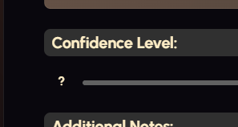  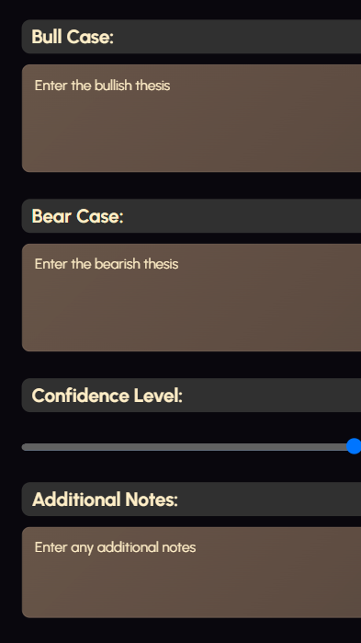 | 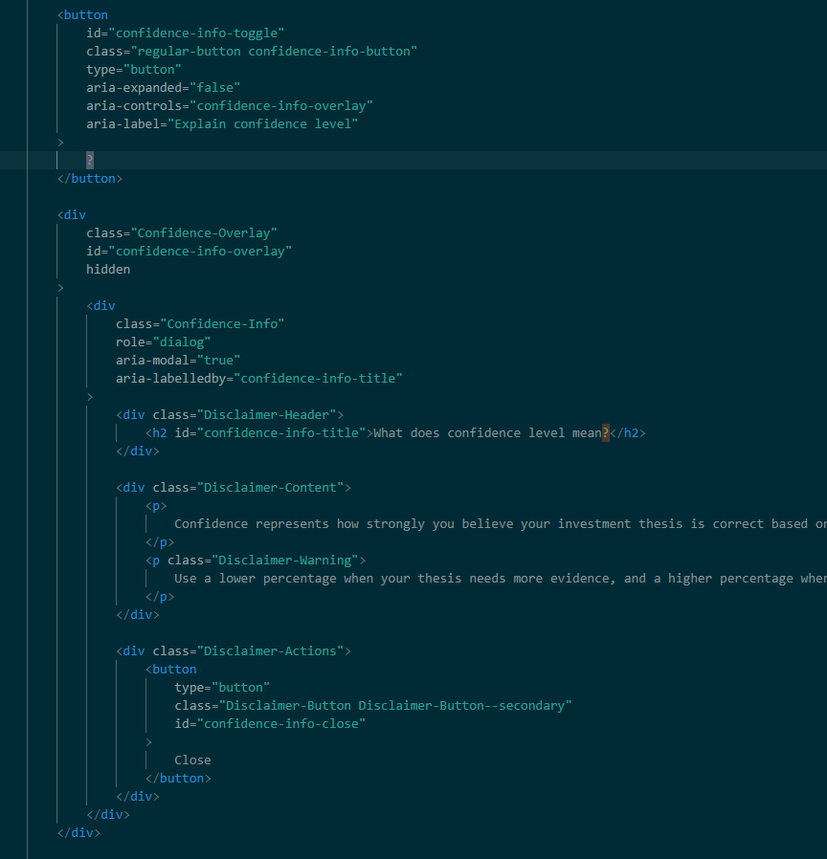  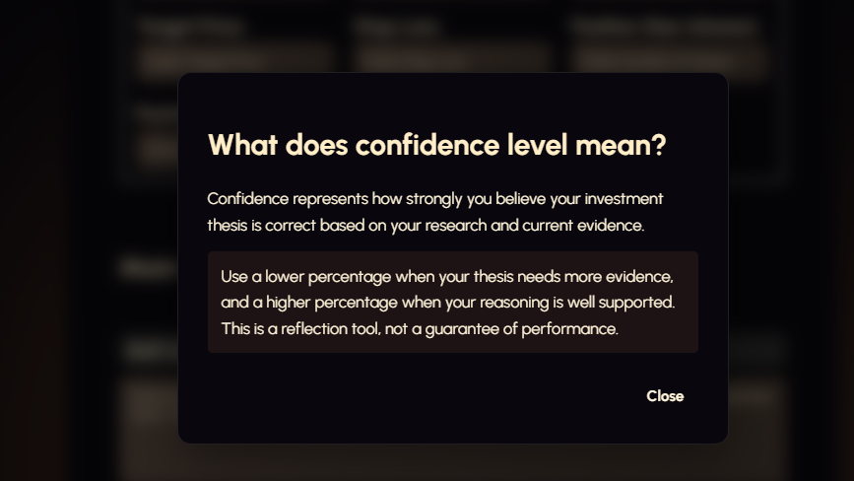   | I changed the placeholder text to be more descriptive of the bear and bull case theses.  I used the same css and code for my disclaimer, as it is a popup too.  You can see that I’ve used the same headers as my disclaimer overlay to keep the styling consistent
1/09/26 | Make the navigation bar sticky because its currently a bit difficult to find when it disappears  Navigation button sizes aren’t getting larger with the increase in VW to a large desktop screen. (font is too small to be aptly visible) |   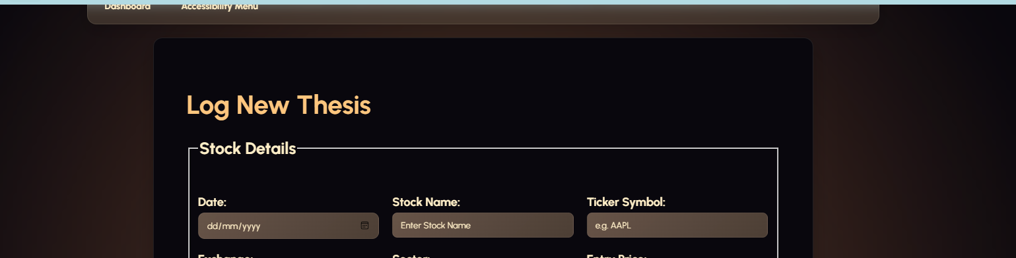
19/09/26 | Add common stock metrics like P/E, EPS, 52week change (%), Market Cap, Free Cash Flow growth (+ or -), Relative P/E ratio (compared to market average), net profit. | 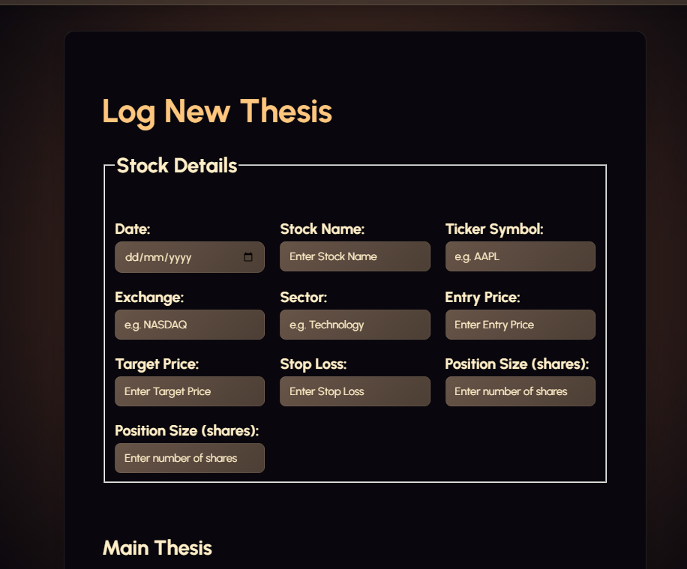  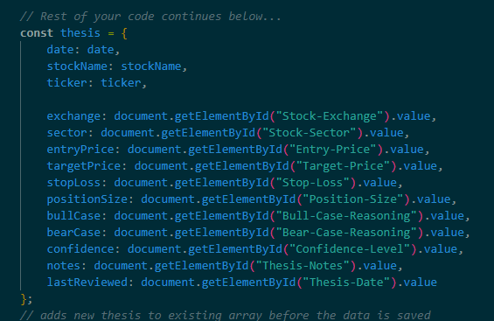  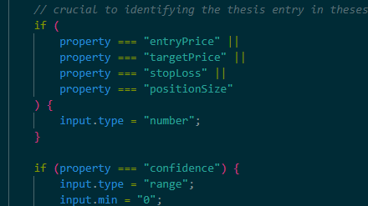 | 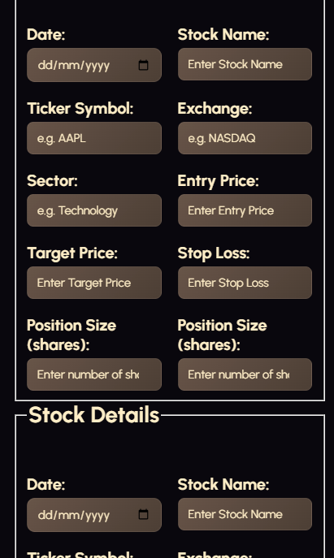  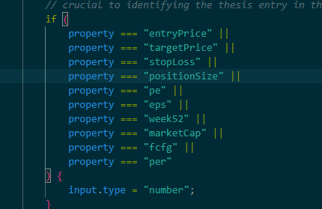  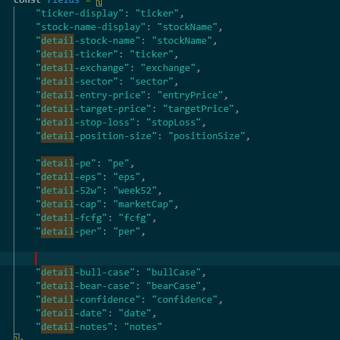  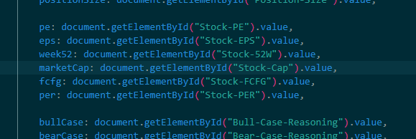  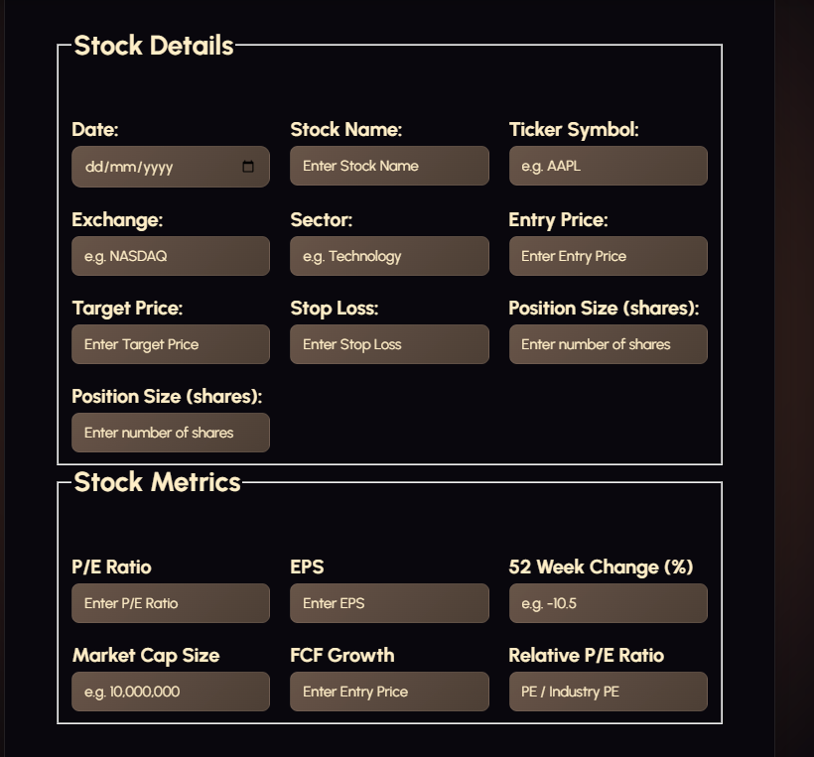 | Addition process:  Copy and pasted the same structure from the stock details section to get the correct styling for a consistent and efficient design.  This is important because my grid layout uses flexbox to shrink on smaller devices, so using the repeated structure and styling ensures that the new section automatically has flex elements applied.  For this section I’m mostly needing to use number inputs, as most stock metrics are a number.  Specification:  Its also important that I do not make any of these sections required, because stock metrics are used differently by every investor, and it would be frustrating to users if I was making it unable to submit their forms for statistics they don’t anaylse.  Added the new categories for the stock metrics inside const theses = object.  Same thing in the const fields object.  And added them to the editButton.addEventListener.  DEBUG – form not submitting  See log on the 19/09/26

Main functional testing table
Add more detailed javascript comments
The final outcome:
Demo video after all testing has been done and features have been added shows the final (for now) product

Changes I’d like to make in the future, if time wasn’t a constraint:

